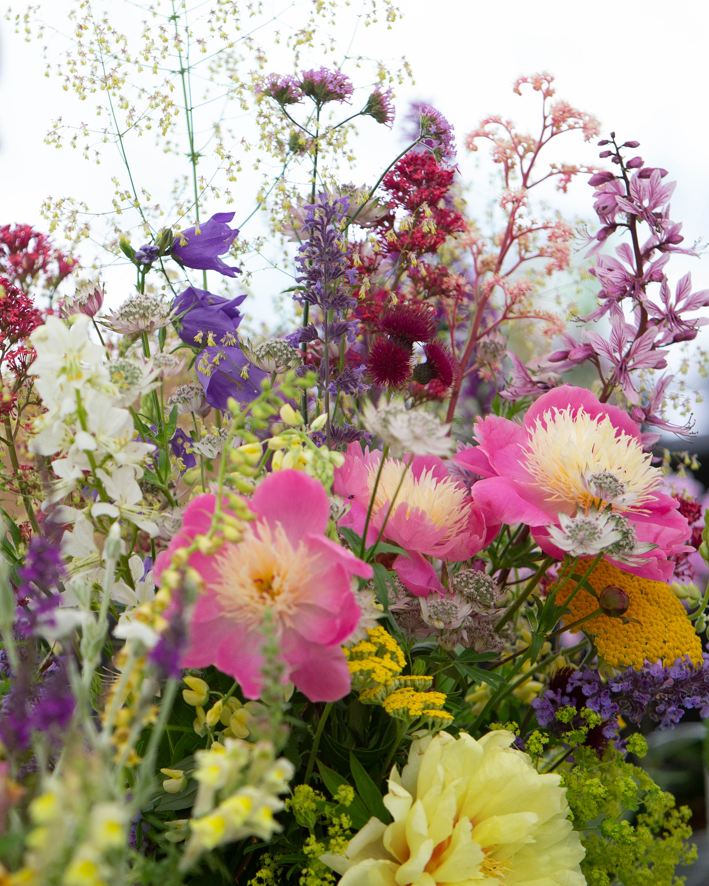


Three Counties, Malvern, WR13 6NW

FLOWER SHOW SCHEDULE

Closing date: Friday 7th June 2024
royalthreecounties.co.uk
01684 584900

Three Counties registered charity no.511868

ROYAL THREE COUNTIES FLOWER SHOW
ENTRIES CLOSE FRIDAY 7 JUNE 2024
JUDGING COMMENCES AT 7AM FRIDAY 14 JUNE 2024

BEST EXHIBIT IN SHOW will receive an Award Card.
BEST EXHIBIT IN EACH SECTION will each receive an Award Card.

SECTION A - CUT FLOWERS AND FOLIAGE

Entry fee for Classes A1 - A12 - 80p
Prizes for Classes A1 - A1 - 1st - £5, 2nd - £3, 3rd - £2

Class A1 One container of Sweet Peas, not more than 9 stems.
Class A2 One container of Roses, not more than 5 Single Head stems.
Class A3 One container of Roses, not more than 5 Cluster Flowered stems.
Class A4 Sweet Williams, one container of not more than 5 stems.
Class A5 One Vase of annuals.
Class A6 One Vase of herbaceous perennials, single cultivar species.
Class A7 One Vase of mixed herbaceous perennials.
Class A8 One Vase of flowering shrub.
Class A9 One Vase of summer bulbs, rhizomes, tubers and/or corms, one species, not more than 5 stems.
Class A10 Frontal display of cut hosta leaves.
Class A11 One bowl of floating flower heads. Bowl not to exceed 300mm diameter.
Class A12 One container of cut fern fronds.

SECTION B - POT PLANTS

Entry fee Classes B1 - B11- 80p
Prizes for Classes B1 - B11 - 1st - £5, 2nd - £3, 3rd - £2

Class B1 One pot of flowering plant(s). Pot not to exceed 260mm diameter. Not specified elsewhere.
Class B2 One pot of foliage plant(s). Pot not to exceed 260mm diameter. Not specified elsewhere.
Class B3 One pot, Pelargonium(s). Pot not to exceed 260mm diameter.
Class B4 One pot, Fuchsia(s). Pot not to exceed 260mm diameter.
Class B5 One pot, Orchid. Pot not to exceed 260mm diameter.
Class B6 Cactus, one pot or pan not to exceed 260mm diameter or equivalent in square pot or pan.
Class B7 Succulent, one pot or pan not to exceed 260mm diameter or equivalent in square pot or pan.
Class B8 One pan, Alpine. Pan not to exceed 260mm diameter measured externally at the top of the pot.
Class B9 One Hosta. Pot not to exceed 260mm diameter.
Class B10 One Miniature Hosta. Pot not to exceed 200mm
Class B11 One Fern. Pot not to exceed 260mm diameter.
Class B12 One climbing plant, flowering. Pot not to exceed 260mm.

SECTION C - FLORAL EXHIBITS

Purchased flowers and foliage may be used for classes C1 - C3.

Entry fee for Classes C1 and C2 80p
Prizes for Classes C1 and C2 1st - £5, 2nd - £3, 3rd - £2
Entry fee for Class C3 £1.
Prizes for Class C3 - 1st £10, 2nd £8, 3rd £6, 4th £4.

Class C1 A Table Exhibit, to be viewed all round. Maximum space allowed 305mm square.
Class C2 A Buttonhole or Corsage
Class C3 A Floral Exhibit depicting Worcestershire. Maximum space 510mm square. Height unlimited.

SECTION D - JUNIORS
Sponsored by the Gloucestershire Federation of Gardening Societies

No Entry fee
Prizes for Classes D1 - D10 - 1st - £5, 2nd - £3, 3rd - £2

Class D1 Up to and including year 6 - Garden in a seed tray, predominantly plant material Approx size: 320mm x 210mm.
Class D2 Years 7 - 11 - Garden in a seed tray. Approx size: 320mm x 210mm
Class D3 Up to and including year 6 - A creature made from fruit and/or vegetables.
Class D4 Years 7 – 11 - A creature made from fruit and/or vegetables.
Class D5 Up to and including year 6 - A bunch of flowers in a jam jar.
Class D6 Years 7 – 11 - A bunch of flowers in a jam jar.
Class D7 Up to and including year 6 – One pot Radish grown in a 15cm diameter pot.
Class D8 Years 7-11 - One pot Radish grown in a 15cm diameter pot.
Class D9 Up to and including year 6 – One pot of summer flowering plant(s) grown from seed in a 15cm diameter pot.
Class D10 Years 7-11 - One pot of summer flowering plant(s) grown from seed in a 15cm diameter pot.

SECTION E - VEGETABLES

Entry fee for Classes E1 - E8 - 80p
Prizes for Classes E1 - E8 1st - £5, 2nd - £3, 3rd - £2

Class E1 One pot or pan of growing salad leaves.
Pot or pan not to exceed 260mm diameter.
Class E2 Peas, one dish of 6 pods.
Class E3 Radish, one dish of 6
Class E4 Broad beans, one dish of 6 pods.
Class E5 Rhubarb natural. One dish of 3, with leaf blades trimmed back to approximately 75mm.
Class E6 One dish of fruit, any variety, no more than 10.
Class E7 Herbs, 3 bunches of cut herbs.
Class E8 Potatoes, one dish of 5.

SECTION F - SPECIALS

Entry fee for ALL classes F1 - F6 - £1.50
Prizes for ALL classes F1 - F6 - 1st - £10, 2nd - £8, 3rd - £6, 4th - £4

Class F1 An established container, or containers, planted with flowering plants suitable for the PATIO. The container/s to be provided by the exhibitor and will be placed on a 610mm x 610mm paving slab. To be judged for all round effect. Container/s must be brought to the Show already planted, if not, it/they will not be accepted into the Show.
Class F2 An established container, or containers, planted with foliage plants suitable for the PATIO. The container/s to be provided by the exhibitor and will be placed on a 610mm x 610mm paving slab. Container/s must be brought to the Show already planted, if not, it will not be accepted into the Show.
To be judged for all round effect.
Class F3 A hanging container not to exceed 360mm diameter planted with flowering plants. Facility for hanging container will be provided.
Class F4 A hanging container not to exceed 360mm diameter planted with foliage plants. Facility for hanging container will be provided.
Class F5 A novelty craft-based display with a Horticultural theme in an area 600mm x 600mm height unlimited.
Class F6 A novelty plant-based display with a Horticultural theme in an area 600mm x 600mm height unlimited.

ENTRIES CLOSE FRIDAY 7th JUNE 2024- NO LATE ENTRIES ACCEPTED

Rules

1 All exhibits must be of the Exhibitor's own growing, except Floral Exhibits section and classes D1 - D6 and F5 and F6. The Committee reserves the right to inspect the premises of Exhibitors and to disqualify for infringement of this rule.
2 Entry forms and fees must reach the Show Secretary by Friday 7 June 2024 at 23:56 hrs. No late entries will be accepted.
3 Only one entry from each address per class allowed, with the exception of Section D.
4 The Royal Three Counties Flower Show will be open from noon on Thursday 13 June until 6.30am on Friday 14 June for exhibitors to stage. The structure will be electrically illuminated throughout the night and security staff will be in attendance throughout the night. However, stewards will only be on duty during the following times to give advice and issue exhibit cards:-
Thursday 13 June - noon to 10.00pm
Friday 14 June - 6.00am to 6.45am
All exhibitors must leave the section by 6.45am. Judging will commence at 7am prompt.
5 Exhibits should be named where possible for the interest and education of visitors. Variety cards will be available from the Stewards.
6 VASES WILL BE AVAILABLE FOR CUT FLOWERS, but exhibitors may supply their own. Please see rule 18 FLORAL FOAM
7 The Society and Committee will take every reasonable care but will not be responsible for any loss or damage.
8 Please place exhibits in a saucer if you wish your entry to be watered during the Show.
9 The decision of the Judges is final. They have the power to withhold any award if the exhibits are deemed to be unworthy.
10 Exhibits and prize cards must not be removed until after 5.00pm on Sunday 16 June 2024. Failure to comply will forfeit prize money. The Society and Committee will try to ensure the safety of all exhibits, but no responsibility will be taken for any loss or damage. Stewards will be in attendance until 5.30pm.
11 IF EXHIBITORS ARE UNABLE TO STAGE THEIR EXHIBIT/S, WOULD THEY PLEASE INFORM THE SHOW OFFICE BY TUESDAY 11 JUNE 2024
12 Any objection must be made in writing to the Secretary before 3.00pm on the first day of the show, together with a deposit of £5.00, which will be retained if the objection is not upheld by the Committee.
13 Prize money will be paid by BACS after the show.
14 The Show is open to all exhibitors who need not be resident within the three counties of Herefordshire, Worcestershire and Gloucestershire.
15 One pass per exhibitor for not fewer than 5 entries.
16 One-vehicle pass will be issued to exhibitors to enable them to deliver and collect their exhibits. Once delivery has been completed, all vehicles must be removed from the showground to the car parks.
The appropriate wrist bands will be given to exhibitors when they collect their class cards.
17 The Society's general show regulations will apply to this section. Copies are available from the main office.
18 RHS and Three Counties Society statement for Floral Foam – 2024 Show Season.
As part of our efforts to improve sustainability and to make environmentally-minded choices when planning our events, we will go ahead with the decision to ban ALL plastic containing foam at all shows in 2024. Many current flora foams on the market are
non-biodegradable and use micro-plastics and due to the nature of its use is very easy for these to get into the water supplies.
We have taken the decision in consultation with exhibitors, competitors, venues, and site managers.
What are the alternatives? There are several great floristry resources online proposing alternatives.
Some to consider include:
Chicken Wire or Metal Pins (kenzan)
Moss
Green Foliage
Tubes and Water
Newspaper
Marbles
Pebbles, Sand, Gravel, Clay
If you are using a degradable alternative to floral foam such as
Agra-wool please contact the relevant show manager to confirm the product is suitable.

