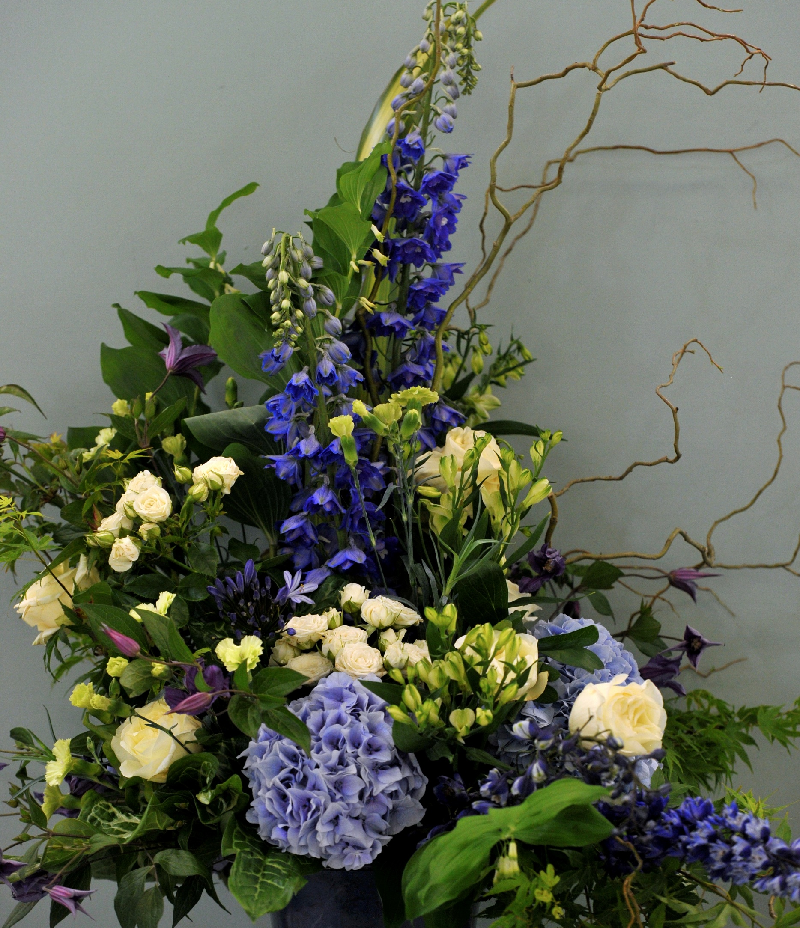

RHS Malvern Spring Festival 7 – 10 May 2026
Three Counties Showground, Malvern, WR13 6NW

Floral Art Schedule

Closing date: Friday 27th February 2026

ENTER NOW at www.rhsmalvern.co.uk/compete Tel : 01684 584900

Three Counties registered charity no.511868 RHS registered charity no. 222879/SCO38262

Judges:

RHS Malvern Spring Festival
7 - 10 May 2026

Floral Art Schedule

Alan Beatty James Burnside
Heather Hume Joan Magee

Exhibits judged in accordance with NAFAS Competitions Manual (Fourth edition) 2023, available at: https://www.nafas.org.uk/product/competitions-manual-2023/

Trophies:
Best in Show– The Gloria Lee Trophy - Donated by George Lee and Family
Reserve Best in Show – Donated by the Three Counties Floral Art Committee
Best Use of Fresh Foliage – Donated by Mrs Cate Morris
Best Use of Colour - Donated by the Three Counties Floral Art Committee
Best Young Arranger – under 30 - Donated by Mr Malcolm Hodges
Best Junior – under 16
Entries in all classes except class 1 are eligible for the above awards.

Prizes:
Class 1 | Judged by all 4 Judges, medal cards awarded.
Class 2 | Judged by all 4 judges, medal cards awarded.
Class 3 | Judged by all 4 judges, medal cards awarded.
Classes 4, 5, 6, 7 & 8 | 1st - £60, 2nd - £45, 3rd - £30
Classes 9, 10, 11 & 12 | 1st - £45, 2nd - £35, 3rd - £30
Classes 13 & 14 | 1st - £25, 2nd - £20, 3rd - £15

Entry Fee – £5.00 per class (No entry fee for classes 1, 2, 3, 13 & 14). Entrants in classes 1,2 and 3 are eligible for a bursary. Entry fees include one complimentary ticket for Thursday, one complimentary ticket for Sunday and one vehicle pass. Exhibitors entering only Classes 7, 8, 10, 13 and 14 will receive one ticket which is valid for Sunday. Exhibitors aged 16 and under will receive one ticket for themselves and one for an accompanying adult.

Closing Date for entries – Friday 27 February 2026

The use of plastic based floral foam is strictly prohibited

THEME – What a Wonderful World

Class 1 – A NAFAS Areas class.
Earthly Beauty
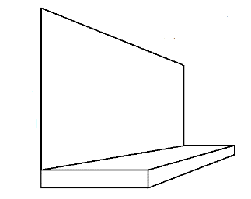
An exhibit
• Staged on a base 30 cm high, painted sage green.
• Space allowed: not to exceed width 240 cm, depth 120 cm,
height from floor including the base 240 cm.
• Background 210 cm high will be provided and painted sage
green.
- Exhibitors may provide their own drapes/backcloth/base cloth and title.
• To be staged by up to five people.
• To be viewed and judged from the front.
• Limited to 9 exhibits.
Please note – Area names may only be displayed after judging

Class 2
Captivating Landscapes
An exhibit.
• Staged on a round base, diameter 122cm, height 10cm, painted black.
• Space allowed: not to exceed diameter 122cm, height optional.
• To be staged by up to two people.
• Title may be included.
• To be viewed and judged all round.
• Limited to 6 exhibits.

Class 3
Live Life in Full Bloom
A pedestal class
• Staged on the floor against a black background.
• Space allowed: not to exceed width 122cm, depth 122cm, height optional.
• Exhibitors may bring their own staging if desired.
• To be viewed and judged from the front.

Class 4
A Dream Garden
An exhibit.
• Staged on the floor in front of a white picket fence 92cm high.
• Space allowed: not to exceed width 120cm, depth 120cm, height optional.
• To be viewed and judged from the front.
British grown plant material should predominate.

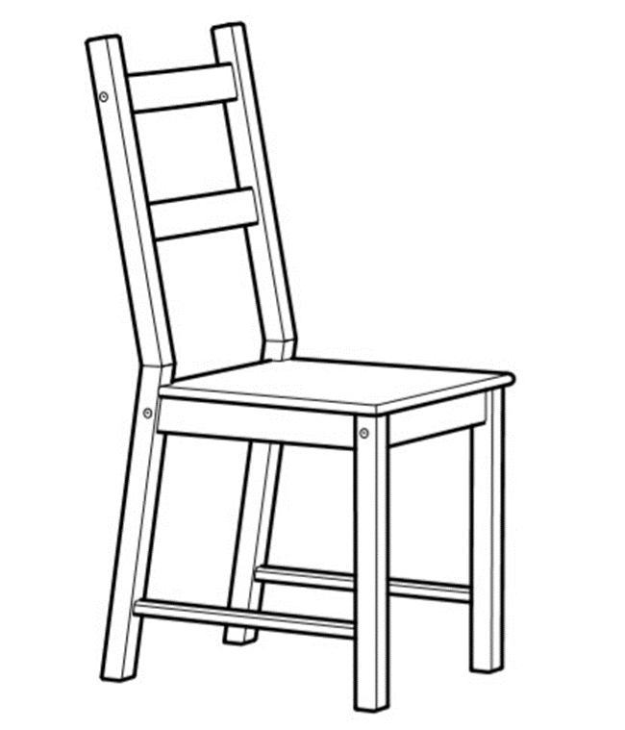
Class 5
A Patchwork of Colour
A pavé
• Staged on the seat of a chair painted blue-grey (provided).
Space allowed: not to exceed seat dimensions width 39cm,
depth 40cm, height from floor 45cm.
- May be arranged on site or brought ready assembled at competitor’s discretion.
- To be viewed and judged from the front
- Limited to 6 exhibits.

Class 6
What a Wonderful World
A contemporary exhibit
• Staged on cylindrical drum diameter 92cm, height 61cm painted Valspar X110R218E ‘Glistening Aqua’.
• Space allowed: not to exceed width 76 cm, depth 76 cm, height optional.
• To be viewed and judged from all round.
• Limited to 6 entries.

Class 7
A Timeless Masterpiece
A miniature exhibit
• Staged on a blue-grey painted coaster on tabling 76cm high covered in forest green
fabric.
• Space allowed: not to exceed width 10cm, depth 10cm and height 15cm.
• May be brought ready assembled.
• To be viewed and judged from the front.
• Limited to 15 exhibits.
NB: an entry in this class only entitles the competitor to one complimentary ticket (Sunday only).

Class 8
Jewels of the Sea
A petite exhibit
• Staged on a block width 25.5cm, depth 25.5cm, height 9.5cm, painted blue-grey
and displayed on tabling 76cm high covered in forest green fabric.
• Space allowed: not to exceed width 25cm and depth 25cm, height optional.
• May be brought ready assembled.
• To be viewed and judged from the front.
• Limited to 15 exhibits.
NB: an entry in this class only entitles the competitor to one complimentary ticket (Sunday only).

Class 9
The Long, Hot Summer
An exhibit
• Staged on a raised square base, width 122cm, depth 122cm, height 25cm, painted black.
• Space allowed: width 122cm, depth 122cm, height optional.
- Competitors may bring their own accessories
• To be viewed and judged all around.
• Limited to 14 exhibits.

Class 10
In a Spin
A craft exhibit
• Designed to be hung from a horizontal rail (provided) approximately 2m from
ground level, hook provided.
• Space allowed: not to exceed width 60cm, depth 60cm, maximum drop from hook
100cm.
• May be brought ready assembled.
• To be viewed and judged all around.
• Limited to 8 exhibits.
NB: an entry in this class only entitles the competitor to one complimentary ticket (Sunday only).

Class 11
It’s Coming Home?
An exhibit
• To be staged on an uncovered table, width 75cm, depth 75cm, height 76cm. Competitors may bring their own table covering.
• Space allowed: not to exceed width 95cm, depth 95cm, height optional.
• Accessories allowed.
• Sides and corners of the table may be decorated.
• To be viewed and judged all round.

Class 12
The Big Bang
An exhibit
• Staged on a cube, width 61 cm, depth 61 cm, height 56 cm
painted in black.
• Space allowed: not to exceed width 100cm, depth 100cm, height optional.
• To be viewed all round and judged from the front.
• Limited to 14 exhibits.

Class 13 – Junior Class - Open to ages under 12 (Age to be stated on entry form)
Winnie the Pooh is 100!
A craft exhibit
• Staged on tabling 76cm high and covered in forest green fabric.
• Space allowed: not to exceed width 76cm, depth 76cm, height optional.
• Natural plant material must be included.
• May be brought ready assembled.
• To be viewed and judged all round.
• Not judged under NAFAS rules
NB: an entry in this class only entitles the competitor to one complimentary ticket plus one ticket for an accompanying adult (Sunday only).

Class 14 - Junior Class - Open to ages under 16 (Age to be stated on entry form)
Winnie the Pooh is 100!
A craft exhibit
• Staged on tabling 76 cm high and covered in forest green fabric.
• Space allowed: not to exceed width 76cm, depth 76cm, height optional.
• Natural plant material to predominate.
• May be brought ready assembled.
• To be viewed and judged from the front.
• Judged under NAFAS rules
NB: an entry in this class only entitles the competitor to one complimentary ticket plus one ticket for an accompanying adult (Sunday only).

REGULATIONS

- The Competition will be judged under the NAFAS Competition Manual (Fourth edition 2023). Exhibitors are advised to read the NAFAS competition regulations which are available at
https://www.nafas.org.uk/product/competitions-manual-2023/
- Exhibitors must arrange their exhibits in the building without assistance with the exception of Classes 5, 7, 8, 10,13 and 14, which must be the unaided work of the exhibitor and may be brought ready assembled. If in the stewards’ opinion work is completed contra to NAFAS regulation the judging panel will be advised. No exhibitor may enter more than one exhibit in any one class.
- Plant material must predominate at all times unless specifically stated otherwise. Please note that plant material should be conditioned to last for the duration of the show.
- Aerosol spray cans of any description must NOT be used inside an enclosed or semi enclosed space.
- The use of plastic based floral foam of any description is strictly prohibited. Exhibitors using plastic based floral foam will be disqualified. Acceptable alternatives to plastic based floral foam can be found here:
https://rhsmalvern.co.uk/wp-content/uploads/2024/10/Floral-Foam-Alternative-Document-V1.pdf
- Please be aware of the RHS Bio-security Regulations which can be found here:
https://rhsmalvern.co.uk/wp-content/uploads/2024/10/Shows-Biosecurity-policy-regulations-2025-v1-18.10.pdf
- The position of exhibits in Severn Hall shall be decided by the Three Counties Agricultural Society Floral Art Committee.
- Exhibits will be watered only if requested. Watering will be carried out at the discretion of the stewards and the right not to water is reserved. Watering will be undertaken at the competitors’ own risk and stewards will not be held responsible for any damage caused.
- All Exhibitors’ property will be at the exhibitor’s risk and the RHS Malvern Spring Festival (Three Counties Agricultural Society) will not be liable for loss or damage from any cause whatsoever. It is advisable that any valuables should be secured.
- All entries must be received by the Floral Art Section no later than Friday 27 February 2026. No entry fee will be refunded and the Committee reserves the right to refuse any entry and in the event of a refusal it is not required to give any reason.
- Each entry must be accompanied by a fee of £5.00 per class, these fees include VAT. Payment to be made via Showing Scene at time of entry. There is no entry fee for Classes 1, 2, 3, 13 and 14.
- If exhibitors are unable to stage their exhibit/s please inform the Floral Art section by Friday 24th April 2026.
- Exhibits may be staged at any time between 10.00 am and 10.30pm on Wednesday 6 May 2026. All exhibitors must leave the competition area after this time and will NOT be re-admitted until after judging is completed and the show is open.

- Judging will commence at 5.30am on Thursday 7 May 2026.
- Competitors will not be allowed to remove exhibits before 5.00pm on Sunday 10 May 2026. Exhibitors must use the gate indicated on their vehicle pass to gain access to the Exhibition Hall, but vehicles will not be admitted until 6.15pm or until after the Showground has been cleared, whichever is earlier.
- Prize money will be forwarded after the show by bank transfer only. Please ensure that bank details are submitted with your entry. Any prize may be withheld or modified if the exhibits are considered undeserving of the prizes offered.
- Queries should be directed to the Floral Art Administrator, Three Counties Showground, Telephone 01684 584900

RHS Malvern Spring Festival
Three Counties Showground, Malvern, Worcestershire WR13 6NW
Tel: 01684 584900 Fax: 01684 584910
Email: info@threecounties.co.uk

