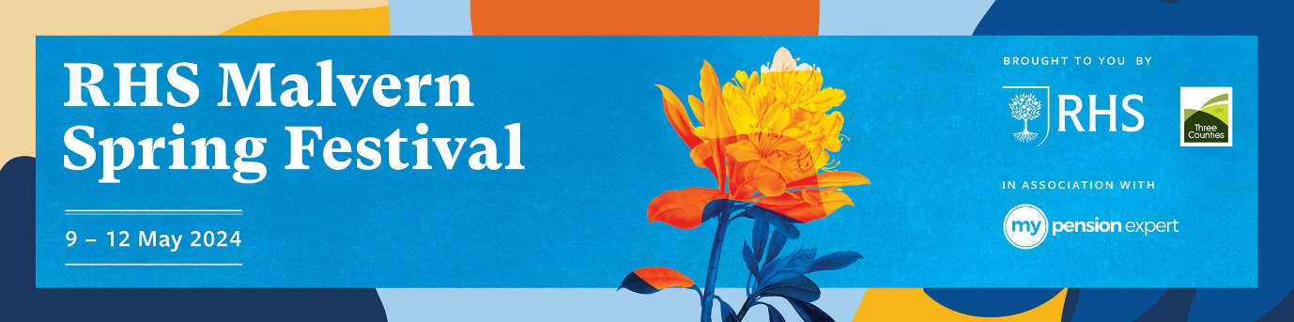

Thursday 9, Friday 10, Saturday 11 & Sunday 12 May 2024

NATIONAL SPECIALIST PLANT SOCIETY SECTION

Conditions for Publicity/Promotional Displays

The RHS Malvern Spring Festival is pleased to offer the following to National Specialist Plant Societies at the 2024 event:

FREE SPACE to stage a floral and/or promotional display from which to sell relevant books (i.e. relating to your specialty), promote membership etc.
National Specialist Plant Societies are permitted to sell plants as well as seeds. Seeds sold should not generally be available through the trade. Plants must have been grown by members of the society. The sale of plants and/or seeds must only take place on the sales tables provided. Any plants or cut flowers used on the display can be sold off at the end of the show: 4pm Sunday 12 May 2024.
50% of your Society’s stand should to be given over to a good plant quality display and/or educational area. Sketched plans of the whole stand to accompany the application form.

Please consider the environmental impact of your exhibit, when staging your display. The use of floral foam is prohibited. Please choose environmentally responsible alternatives where possible. Further details regarding sustainability rules and regulations are available here.

Seed packets should be correctly labelled with the name and address of the Society, the name of the plant and date of packaging.

If your Society wishes for their display to be judged by RHS Judges, please indicate on the digital application form. (Sales tables are not judged. Only the display will be judged).

Prize money for RHS judging is as follows: Gold £650.00
Silver-Gilt £425.00
Silver £250.00
Bronze £125.00.

Closing Date for entries Monday 4 December

