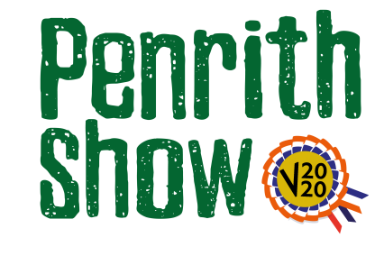
Open Poultry
Sponsored by the Leo Group
Classes
Note: There are no classes for cross bred poultry, only pure breeds
Judge – Ian Allonby
Class 1 – Large Fowl
Description - Hard or Soft Feather
In regard to the required video, exhibitors are encouraged to video their bird and maybe telling a bit about themselves and the bird itself.

Class 2 – Hard Feather
Description - Bantam
In regard to the required video, exhibitors are encouraged to video their bird and maybe telling a bit about themselves and the bird itself.

Class 3 - Soft Feather
Description - Bantam
In regard to the required video, exhibitors are encouraged to video their bird and maybe telling a bit about themselves and the bird itself.

Class 4 – Waterfowl
In regard to the required video, exhibitors are encouraged to video their bird and maybe telling a bit about themselves and the bird itself.

Entry Fee - £3.00

Prize Monies
1st - £20
2nd - £10
3rd - £5

Rosettes will be awarded for a special for each class and a champion and reserve

