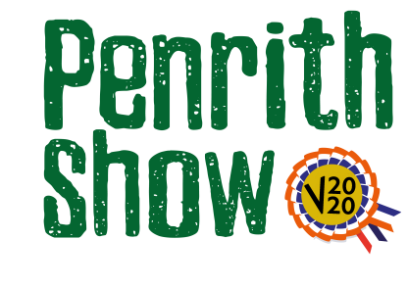
Horse Section
Sponsored by Penrith Building Society
Classes
Judge – Richard Nicol
Class 1 - Riding Club/Pony Club Horse/Pony
Descriptor – any pony 4 yrs. and over to be shown mounted.
With regard to the required video it should show the horse moving away from the camera and coming back

Class 2 – Hunter Class
Descriptors:
- Lead Rein Pony of Hunter Type. Mare or Gelding, 4 years old and over, not exceeding 122cms. Riders not to have attained their 9th birthday before 1st January in the current year
- Hunter Type not exceeding 133cms.
- Hunter Type not exceeding 143cms.
- Hunter Type not exceeding 153cms.
- Small Ridden Show Hunter under 15.2hh, 4 years old and over
- Lightweight Ridden Show Hunter 4 years old and over, to carry up to 12st 7lbs
- Medium weight Ridden Show Hunter 4 years old and over, to carry over 12st 7 lbs but not exceeding 14 st.
- Heavyweight Ridden Show Hunter 4 years old and over, to carry over 14st

With regard to the required video it should show the horse moving away from the camera and coming back

Class 3 – Open Concourse d’ Elegance,
Descriptor - for horses/ponies, 4years old and over, lead rein, ridden or driven.
With regard to the required video it should show the horse moving away from the camera and coming back

Entry Fee - £5.00

Prize Monies
1st - £25
2nd - £15
3rd - £10

