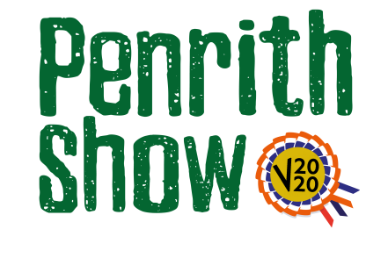
Home Made Section
Sponsored by Cranstons
Classes
Judges – Laura Harker (Produce and Handicraft)
Rod Ireland (Photography)
Class 1 - Produce: 4 decorated cupcakes
Description - decoration to be judged. This can be four identically decorated cupcakes or different designs.
Have fun with the required video – maybe take them at all angles or explain how you made them?

Class 2 – Handicraft: Something crafted at home or in the garden during lockdown
Description - this class is intended for amateurs and the item can be anything in any medium.
Have fun with the required video – maybe take it at all angles or explain how you made it and when?

Class 3 – Photograph: ‘Lockdown Life’
Description –
explain where and when you took it?

- All exhibits must be the work of the exhibitors only
- No exhibit is allowed which has previously won a prize at Penrith Show.

Entry Fee - £3.00

Prize Monies
1st - £15
2nd - £10
3rd - £5

