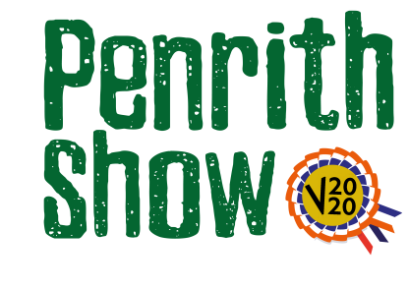
Home Grown Section
Sponsored by Cranstons
Classes
Judge – Martin Ogle
Class 1 - Vase of mixed garden flowers
Description – a vase of seasonal flowers picked from your garden or allotment.
Have fun with the required video – maybe take it from the garden or allotment from where they came?

Class 2 – Selection of homegrown vegetables and/or fruit
Description – a display of your best seasonal fruit and/or vegetables from your garden or allotment.
Have fun with the required video – maybe take it from the garden or allotment from where they came?

- All exhibits must be the work of the exhibitors only
- No exhibit is allowed which has previously won a prize at Penrith Show.

Entry Fee - £3.00

Prize Monies
1st - £15
2nd - £10
3rd - £5

