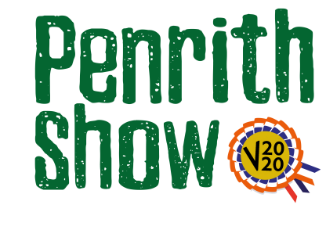
Dog Show
Sponsored by Cumbrian Stone
Also H&H Reeds who are supplying an Acrylic picture of best Dog
Classes
Judge – Tom Barr
Class 1 – Best Dog
Descriptor – this can be any dog and the video can include the dog walking, doing tricks, anything you feel can best show off your dog.

Entry Fee - £3.00

Prize Monies
1st - £20
2nd - £10
3rd - £5
Also an Acrylic picture of best Dog supplied by H&H Reeds

