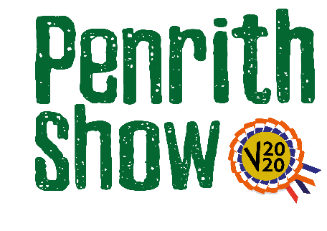

Children’s Section
Sponsored by Cartmell Shepherd Solicitors
Classes
Judge – Joy Albert
Class 1 – 5 and under - A farm animal in any medium
Description – the farm animal can be made from any material, 2D or 3D.
Remember - your image needs a caption as well as the PVS 2020 sign.
Have fun with the required video – maybe take it at all angles or explain how you made it and what with?

Class 2 – 6 to 8 years - A rainbow in any medium
Description – the rainbow has been seen a lot recently in support of the NHS. The rainbow can be created using any medium.
Remember - your image needs a PVS 2020 sign.
Have fun with the required video – maybe take it at all angles or explain how you made it and what with?

Class 3 - 9 to 12 years - A junk model spacecraft
Description – a spacecraft made from recycled materials. Perhaps your model could be the next Space X rocket?
Remember - your image needs a PVS 2020 sign
Have fun with the required video – maybe take it at all angles or explain how you made it and what with?

Class 4 – 13 to 16 years - An origami animal
Description – transform a square sheet of paper into a sculpture of an animal using this paper folding art form. Remember - your image needs a PVS 2020 sign.
Have fun with the required video – maybe take it at all angles or explain how you made it?

Entry Fee - £1
Prize Monies for each class
1st - £5
2nd - £3
3rd - £2

