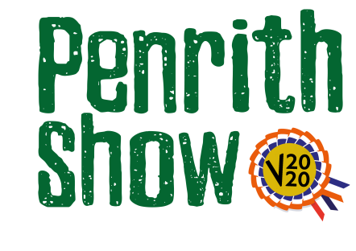
Cattle Section – Young Handler
Sponsored by Lowther Estates
Classes
Judge – Philip Hallhead
Class 1 – Inter Dairy Young Handler Championship
Descriptor - Any dairy calf to complement the handler. Handler to be 10-16 years old
In regard to the video, exhibitors are encouraged to video themselves walking their animal around and once stood, tell a bit about themselves and the animal and how they made it ready to show.

Class 2 – Inter Dairy Young Handler Championship
Descriptor - Any dairy calf to complement the handler. Handler to be 17-26 years old
In regard to the video, exhibitors are encouraged to video themselves walking their animal around and once stood, tell a bit about themselves and the animal and how they made it ready to show.

Class 3 – Young Handler Beef Calf
Descriptor - A Beef Calf (Any Breed). Calf to complement the handler. Handler to be 10-16 years old
In regard to the video, exhibitors are encouraged to video themselves walking their animal around and once stood, tell a bit about themselves and the animal and how they made it ready to show.

Class 4 – Young Handler Beef Calf
Descriptor - A Beef Calf (Any Breed). Calf to complement the handler. Handler to be 17-16 years old
In regard to the video, exhibitors are encouraged to video themselves walking their animal around and once stood, tell a bit about themselves and the animal and how they made it ready to show.

Entry Fee - £5.00

Prize Monies
1st - £25
2nd - £15
3rd - £10

