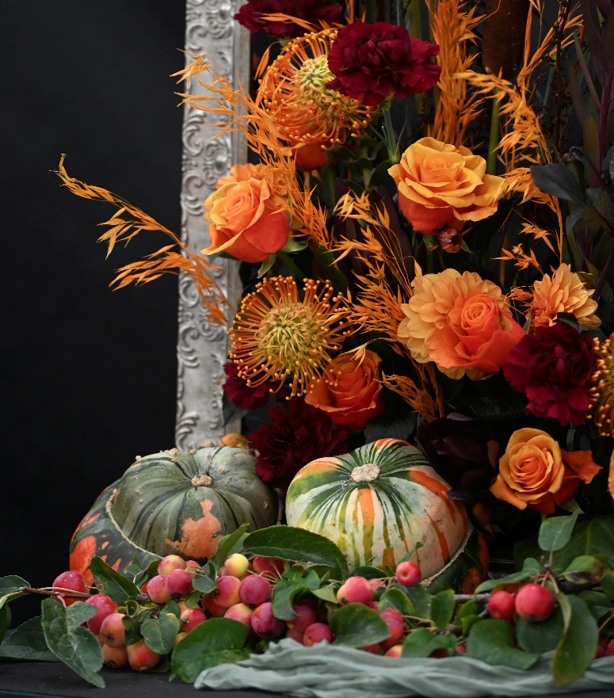

Malvern Autumn Show 25 – 27 September 2026
Three Counties Showground, Malvern, WR13 6NW. T: 01684 584900

Floral Art Schedule
Closing date: Monday 17th August 2026

ENTER NOW at malvernautumn.co.uk/compete
______________________________________________________________________________________ _

Three Counties registered charity no.511868 RHS registered charity no. 222879/SCO38262

MALVERN AUTUMN SHOW
25, 26 & 27 SEPTEMBER 2026
FLORAL ART SCHEDULE

Judges: Margaret Rumens and Dawn Weaver

Exhibits will be judged in accordance with the NAFAS Competitions Manual

(Fourth edition) 2023 with the exclusion of classes 9 and 14.

Trophies and awards: To be awarded to individual exhibitors

BEST IN SHOW TROPHY – THE NEVILLE PARKER CUP

CARDS AWARDED FOR: BEST USE OF COLOUR, BEST USE OF FRESH FOLIAGE AND RESERVE BEST IN SHOW

CLASSES 1 & 2 & 3 – MEDAL CARDS WILL BE AWARDED
Bursaries available for classes 1 & 2 & 3
CLASS 9 100 voucher from Jonathan Moseley

Prizes: 1st 2nd 3rd
£ £ £
Class 1 Medal cards awarded
Class 2 Medal cards awarded
Class 3 Medal cards awarded
Class 4, 6 20 15 10
Class 5, 7, 8, 9,10, 11, 15 12 10
12,13, 14,15

ENTRY FEE: £5 per class entered (except Classes 1,2, 3,14 and 15). Entry fee includes 1 ticket for Friday and 1 ticket for Sunday and 1 vehicle pass. Exhibitors entering only Classes 7,8,10,13,14 and 15 will receive 1 ticket which is valid for Sunday. Exhibitors aged 16 and under will receive a ticket for themselves and one for an accompanying adult. Where entry numbers are limited entries will be treated in order of application.

Closing date for entries Monday 17 August 2026

THEME – The Arts

Class 1
A Winter’s Tale
An exhibit
To be staged by up to three people.
- Incorporating a black metal archway (provided), measuring width 104cm, depth 68cm
and 229cm height to be positioned at the competitors’ discretion.
- Staged on a base width 240cm, depth 120cm, height 30cm, painted sage green.
- Space allowed: not to exceed width 240cm, depth 120cm, height from floor
including the base 240cm.
- Background 210cm high will be provided and painted sage green.
- Exhibitors may provide their own drapes/backcloth/base cloth and title.
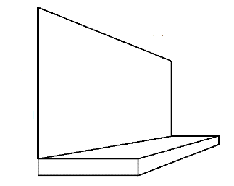
- Fresh plant material to predominate.
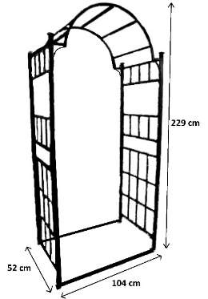
- To be viewed and judged from the front.
- Medal cards will be awarded.
- Limited to 5 exhibits.
Please note – Area or club names may only be
displayed after judging

Class 2
Twas’ the Night Before Christmas
A tablescape
To be staged by up to two people.
- Staged on a table, width 75cm, length 183cm, height 76cm.
  - Space allowed: not to exceed width 75cm, length 223cm, height optional.
  - Natural plant material to predominate, artificial plant material may be used.
  - Table covering and accessories not supplied.
  - To be viewed and judged all round.
- Medal cards will be awarded.
- Limited to 10 exhibits

Class 3
Ode to Autumn
A pedestal class
• Staged on the floor against a cream background.
• Space allowed: not to exceed width 122cm, depth 122cm, height optional.
• Exhibitors may bring their own staging if desired.
- To be viewed and judged from the front.
- Medal cards will be awarded.
British grown plant material should predominate.

Class 4
Walk on the Wildside
An exhibit.
• Staged on the floor in front of a white picket fence 92cm high.
• Space allowed: not to exceed width 120cm, depth 120cm, height optional.
• To be viewed and judged from the front.
British grown plant material should predominate.
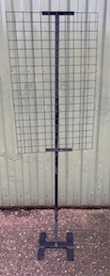
Class 5
Graffiti
A craft class
• Staged on a grid width 56cm, length 91cm comprised of 5cm
squares, incorporating a canvas (not supplied).
• Space allowed: not to exceed width 100cm, depth optional,
height 150cm.
- May be arranged on site or brought ready assembled at
competitor’s discretion.
- To be viewed and judged from the front.
- Limited to 6 exhibits.

Class 6
Three Choirs
A still life exhibit
• Staged on tabling 76 cm high and covered in forest green fabric.
• Space allowed: not to exceed width 76 cm, depth 76 cm, height optional.
• To be viewed and judged from the front.

Class 7
A Perfect Palette
A miniature exhibit
• Staged on a blue-grey painted coaster on tabling 76cm high covered in forest green
fabric.
• Space allowed: not to exceed width 10cm, depth 10cm and height 15cm.
• May be brought ready assembled.
• To be viewed and judged from the front.
• Limited to 15 exhibits.
NB: an entry in this class only entitles the competitor to one complimentary ticket
(Sunday only).

Class 8
Movement
A petite exhibit
• Staged on a block width 25.5cm, depth 25.5cm, height 9.5cm, painted blue-grey
and displayed on tabling 76cm high covered in forest green fabric.
• Space allowed: not to exceed width 25cm, depth 25cm, height optional.
• May be brought ready assembled.
• To be viewed and judged from the front.
• Limited to 15 exhibits.
NB: an entry in this class only entitles the competitor to one complimentary ticket (Sunday only).

Class 9
Express Yourself
A chance for anyone who may wish to try their hand at entering a flower arranging competition. If you love flowers
and being creative with natural mediums then why not have a go?
A floral design in a container of your choice showcasing the best of seasonal
flowers, foliage and berries.
- Staged on tabling 76cm high and covered in forest green fabric.
• Space allowed: not to exceed width 60cm, depth 60cm, height 70cm.
• Natural plant material must be included.
• May be brought ready assembled.
• To be viewed and judged all round.
• Judged by Jonathan Moseley
Not judged under NAFAS rules

Class 10
Art Deco
A craft exhibit
Create an item inspired by the Art Deco era
• Staged on tabling 76cm high and covered in forest green fabric.
• Space allowed: not to exceed width 30cm, depth 30cm, height optional.
• May be brought ready assembled.
• To be viewed and judged all round.
NB: an entry in this class only entitles the competitor to one complimentary ticket (Sunday only).

Class 11
Line Dancing
A parallel exhibit
- Staged on a cube, width 61cm, depth 61cm, height 56cm painted black.
• Space allowed: not to exceed width 100cm, depth 100cm, height optional.
• To be viewed all round and judged from the front.
• Limited to 14 exhibits.

Class 12
A Christmas Carol
An exhibit
  - Staged on two ribbed cylinders painted in Valspar Marsh Grass. Cylinder 1
measures 35.5cm diameter x height 60cm, cylinder 2 measures 35.5cm diameter
x height 100cm.
  - Space allowed: not to exceed width 120cm, length 120cm, height optional.
  - To be viewed and judged all round.
- Limited to 10 exhibits.

Class 13
Strictly Sparkle
An exhibit
• Designed to be hung from a horizontal rail (provided) approximately 2m from
ground level, hook provided.
• Space allowed: not to exceed width 60cm, depth 60cm, maximum drop from hook
100cm.
- May be brought ready assembled.
• To be viewed and judged all around.
• Limited to 8 exhibits.
NB: an entry in this class only entitles the competitor to one complimentary ticket (Sunday only).

Class 14 – Junior Class - Open to ages under 12 (Age to be stated on entry form)
All I Want for Christmas
A craft exhibit
• Staged on tabling 76cm high and covered in forest green fabric.
• Space allowed: not to exceed width 76cm, depth 76cm, height optional.
• Natural plant material must be included.
• May be brought ready assembled.
• To be viewed and judged all round.
• Not judged under NAFAS rules
NB: an entry in this class only entitles the competitor to one complimentary ticket plus one ticket for an accompanying adult (Sunday only).

Class 15 - Junior Class - Open to ages under 16 (Age to be stated on entry form)
A Box of Delights
A craft exhibit
• Staged on tabling 76 cm high and covered in forest green fabric.
• Space allowed: not to exceed width 76cm, depth 76cm, height optional.
• Natural plant material to predominate.
• May be brought ready assembled.
• To be viewed and judged from the front.
• Judged under NAFAS rules
NB: an entry in this class only entitles the competitor to one complimentary ticket plus one ticket for an accompanying adult (Sunday only).

REGULATIONS

- With the exception of classes 9 and 14, the Competition will be judged under the NAFAS Competition Manual (Fourth edition 2023). Exhibitors are advised to read the NAFAS competition regulations which are available at
https://www.nafas.org.uk/product/competitions-manual-2023/
- Exhibitors must arrange their exhibits in the building without assistance with the exception of Classes 5, 7, 8, 9, 10, 13, 14 and 15, which must be the unaided work of the exhibitor and may be brought ready assembled. If in the stewards’ opinion work is completed contra to NAFAS regulation the judging panel will be advised. No exhibitor may enter more than one exhibit in any one class.
- Plant material must predominate at all times unless specifically stated otherwise.
- Aerosol spray cans of any description must NOT be used inside an enclosed or semi enclosed space.
- The use of plastic based floral foam of any description is strictly prohibited. Exhibitors using plastic based floral foam will be disqualified. Acceptable alternatives to plastic based floral foam can be found here:
https://rhsmalvern.co.uk/wp-content/uploads/2024/10/Floral-Foam-Alternative-Document-V1.pdf
- Please be aware of the RHS Bio-security Regulations which can be found here:
https://rhsmalvern.co.uk/wp-content/uploads/2025/10/2026-Shows-Biosecurity-Policy-Regulations.pdf
- The position of exhibits in Severn Hall shall be decided by the Three Counties Agricultural Society Floral Art Committee.
- Exhibits will be watered only if requested.
- All Exhibitors’ property will be at the risk of the Exhibitor and the Malvern Autumn
Show (Three Counties Agricultural Society) will not be liable for the loss or damage from any cause whatsoever. It is advisable that any valuable accessory should be secured to the exhibit.
- All entries must be received by the Floral Art Section not later than Monday 17 August
2026. Notification will be sent to unsuccessful entrants within 48 hours of closing date of entries and their entry fee will be refunded. Otherwise no entry fee will be refunded and the Committee reserves the right to refuse any entry and in the event of a refusal it is not
required to give any reason.
- Each entry must be accompanied by a fee of £5.00 per class, these fees include
VAT. All remittances in payment of fees shall be by credit card, debit card or cheques
made payable to ‘TCAS’. There is no entry fee for Classes 1, 2, 3, 14 and 15.
- If exhibitors are unable to stage their exhibit/s please inform the Floral Art section by
Friday 21 August 2026.
- Exhibits may be staged at any time between 10.30 am Thursday 24 September
2026 and 5.00am Friday 25 September 2026. All exhibitors must leave the competition
area after this point and will NOT be re-admitted until after judging is completed and the
Show is open.
- Judging will commence at 5.30 am on Friday 25 September 2026.
- Competitors will not be allowed to remove exhibits before 5.15pm on Sunday 27
September 2026. Vehicles to use the gate indicated on their vehicle pass to gain access
to the Exhibition Hall but will not be admitted until 6.15pm or until after the Showground
has been cleared, whichever is the earlier.
- Prize money will be forwarded after the Show. Any prize may be withheld or modified
if the exhibits are considered undeserving of the prizes offered.
- Queries should be directed to the Floral Art Administrator, Three Counties
Showground, Telephone 01684 584900

