Hope Show
Light Horse Schedule
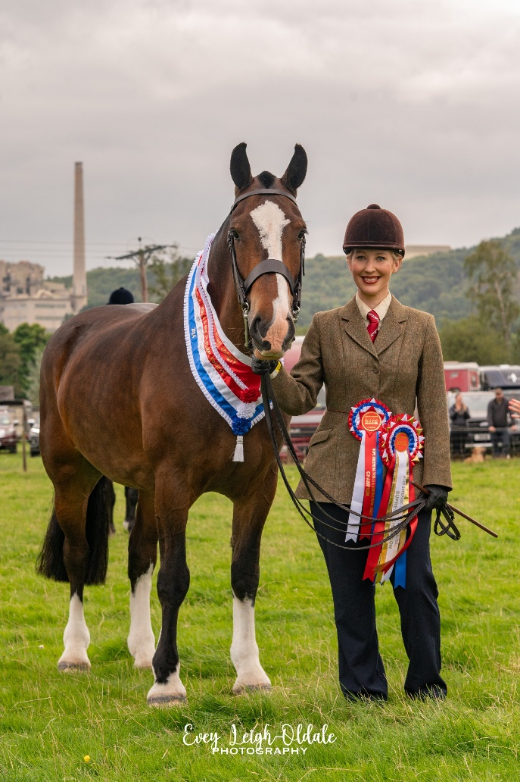

AUGUST 25TH 2025
BANK HOLIDAY MONDAY
Hope Showground, Marsh Farm, Hope,
Hope Valley, Derbyshire, S33 8RZ

Hope Show 2024 Horse Classes
Horse Section Secretary: Mrs Kate White, Moscar Cross Farm, Moscar, Sheffield, S6 6GL
Tel: 07969 250774 Email: kate.e.white@hotmail.com

All entry fees must be made through: www.showingscene.com

All entries must be made by Saturday 17th August 2025
No late or telephone entries allowed.
Hard hats to the current British Standard MUST be worn at all times whilst mounted on the showground..
ALL stallions and colts, 2 years old and over, must be adequately bitted.
Where the height of a horse or pony is specified in any class, the judge, steward or other official may require such an animal to be measured unless the animal has a current official measurement certificate issued by the Joint Measurement Scheme.
All equines attending the showground must have up to date Equine Influenza vaccinations, the organisers reserve the right to check vaccination passports at any time.
The exercising of horses/ponies will only be allowed in the designated collecting rings. No exercising may occur in the box park.
The parent or guardian must, if required, produce to the Secretary, a certified copy of the entry of birth of any child competing in the children’s classes within seven days of the show.
All exhibitors and competitors must be covered by a Public Liability Policy including show use. The Society reserves the right to require any exhibitor to produce proof that a suitable Policy is in force.
The decision of the judges will be regarded as final.
Objections must be lodged with the show secretary in writing up to 15 minutes after the completion of a class and must be accompanied with a deposit of £100 which will be returned if the complaint is upheld. All timings are approximate and subject to change and it is the competitor’s responsibility to present themselves in the ring for the start of their class.
The committee reserve the right to amalgamate, divide or cancel any classes and refuse entry to, or remove from any class any person(s);
(a) that behave in an irresponsible or offensive manner or (b) whose horse/pony they consider unfit to compete.
Each competitor will be issued with an entry pass and one other pass into the show. Anyone else accompanying the competitor must purchase an entry ticket in advance. Failure to do so may result in you being refused entry to the lorry park.
ALL competitors take part at their own risk. The organisers do not hold themselves responsible for any accident that might occur to horse, rider, property or spectator.
Prize money will be 1st - £15, 2nd - £10, 3rd - £7. If there are 3 or less entries prize money will only be given to first place, between 4-6 entries prize money will be given to first and second and 7 or more entries prize money will be given to third place.
ENTRIES CLOSE SATURDAY 17th AUGUST 2025
Entries must be made through www.showingscene.com and payment must be made through the website.

Main Ring – 12.30pm prompt start

1.Fancy Dress – To be judged by the show president. Ridden or in-hand fancy dress. Open to competitors of all ages. Mares or geldings, 4years+, any height.

Ring 2 – 9.00am start

Working Hunter Classes

Judge TBC

Classes 2 -6 are limited to 15 competitors
Entry Fees for Classes 2-6 - £12 per Class. Prizes 1st £15 2nd £10 3rd £7

- Cradle Stakes (lead rein allowed) – Mare or Gelding, 4 years old and over, ponies not to exceed 14.2hh. Combination not to have won a working hunter class. Jumps will not exceed 20cm.
- Novice Pony - Mare or Gelding, not exceeding 148cms, 4 years old and over. Combination not to have won a working hunter classes.
- Novice Horse - Mare or Gelding, exceeding 148cms, 4 years old and over. Combination not to have won a working hunter classes.
- Open Pony - Mare or Gelding, not exceeding 148cms, 4 years old and over. Combination not to have won more than 1 working hunter classes.
- Open Horse - Mare or Gelding, exceeding 148cms, 4 years old and over. Combination not to have won more than 1 working hunter classes.
- Mountain & Moorland - open to ponies registered with their respective Pure-Bred Societies, 4yrs or over, mare or gelding, riders any age. Fences not to exceed 60cms.
- Working Hunter Championship – 1st and 2nd place from classes 2-7 to come forward for the Championship.

Ring 2 – Not to start before 1.30pm

Show Jumping Classes Judge – Mrs M Skelly
Entry Fees for classes 8-13 £12 per Class. Prizes 1st £15 2nd £10 3rd £7
- Tiny tots – for children under 10 years old. Fences not to exceed 20cm
- Novice Show Jumping – combination not to have won more than one show jumping class. Jumps not to exceed 50cm the first round. Horses and ponies will compete together but will be placed separately if there are sufficient entries.
- Intermediate Show Jumping – Jumps not to exceed 75cm in the first round. Horses and ponies will compete together but will be placed separately if there are sufficient entries.
- Open Show Jumping – Jumps not to exceed 90cm in the first round. Horses and ponies will compete together but will be placed separately if there are sufficient entries
- Chase Me Charlie – open to any horse or pony, rider any age.

Ring 3 - Not before 9.00am

Mountain and Moorland Classes Judge – Ms M Hewitt
Entry Fees for Classes 14-16 and 18-20 £12 per Class. Prizes 1st £15 2nd £10 3rd £7

Mountain and Moorland In-hand Classes
- Mountain & Moorland In-Hand Small Breeds – Stallion, mares or geldings. Open to ponies registered with their respective Pure-Bred Societies of Dartmoor, Exmoor, Shetland, Welsh A & B. Foreign M&M breeds welcome but must be registered with their respective societies.
- Mountain & Moorland In-Hand Large Breeds - Stallion, mares or geldings. Open to horses / ponies registered with their respective Pure-Bred Societies of Connemara, Dales, Fells, Highland, New Forest and Welsh C or D. Foreign M&M welcome but breeds must be registered with their respective societies.
16.Mountain & Moorland In-Hand Youngstock - Colts, Fillies or Geldings 1, 2 or 3 years old. Open to ponies registered with their respective Pure-Bred Societies of Connemara, Dales, Dartmoor, Exmoor, Fell, Highland, New Forest, Shetland, Welsh A, B, C and D.
17.In-hand Mountain and Moorland Championship - 1st and 2nd places from classes 13-15 to come forward for the Championship. Champions are invited to the Supreme Championship at the end of showing classes.

Ridden Mountain and Moorland Ridden Classes
- Ridden Mountain & Moorland Lead Rein - Mares or geldings, 4 years old and over. Open to ponies registered with their respective Pure-Bred Societies of Connemara, Dales, Dartmoor, Exmoor, Fell, Highland, New Forest, Shetland, Welsh A, B, C and D. Rider 10 years old and under.
- Ridden Mountain & Moorland Small Breeds - Stallion, mares or geldings, 4 years old and over. Open to ponies registered with their respective Pure-Bred Societies of Dartmoor, Exmoor, Shetland, Welsh A & B. Foreign M&M breeds welcome but must be registered with their respective societies. Rider any age.
- Ridden Mountain & Moorland Large Breeds - Stallion, mares or geldings, 4 years old and over. Open to horses / ponies registered with their respective Pure-Bred Societies of Connemara, Dales, Fells, Highland, New Forest and Welsh C or D. Foreign M&M welcome but breeds must be registered with their respective societies. Rider any age.
- Ridden M&M Championship - 1st and 2nd places from classes 17-18 to come forward for the Championship. Champions are invited to the Supreme Championship in the Main Ring at 2.50pm approx.

Ring 3 – Not before 1.00pm
Ridden Horse Classes – Horse to exceed 152cms.

Judge – Ms M Hewitt
Entry Fees for classes 22-26 £12 per Class. Prizes 1st £15 2nd £10 3rd £7

22.Ridden Coloured Horse - Mare, gelding or stallion, 4 years old and over, exc 14.2hh. Rider any age
- Ridden Veteran Horse - Mare, gelding or stallion, 16 years old +, exc 14.2hh. Rider any age
- Novice Ridden Horse – Mare, gelding or stallion, 4 years old and over, exc 14.2hh. Combination not to have won a ridden show together. Rider any age.
- Open Ridden Horse – Mare, gelding or stallion, 4 years old and over, exc 14.2hh. Rider any age.
- Open Ridden Hunter - Mare, gelding or stallion, 4 years old and over, exc 14.2hh. Rider any age.
- Ridden Horse Championship Championship – 1st and 2nd places from classes 22-26 to come forward for the Championship. Champions are invited to the Supreme Championship

Ring 4 – To start at 9.00am

In-hand classes

Judge – Mrs T Langton
Entry Fees £12 per class. Prizes 1st £15 2nd £10 3rd £7

- Best turned out horse / pony – any age, any height, any breed. Handler any age.
- Open Youngstock – filly, colt, mare or gelding, 1, 2 or 3 years old. Open to any breed.
- Coloured horse / pony – Mare, gelding or stallion, any age, any height. Handler any age.
- Hunter type horse / pony - Mare, gelding or stallion, any age, any height. Handler any age.
- Cob – Mare, gelding or stallion, any age, any height. Handler any age.
- Minature / Shetland – any breed and age. Not to exceed 42 inches.
34. Veteran In-hand pony - Mare or Gelding, 16 years + Not to exceed 14.2hh
35. Veteran In-hand horse - Mare or Gelding, 16 years + Exceeding 14.2hh
36. In-hand Championship - 1st and 2nd places from classes 28-34 to come forward for the Championship.

37.Young Handler 10 years & under - An adult may accompany handler. To be judged on handler and the handler’s ability to show a horse/pony appropriately, not the horse/pony.
38.Young Handler 11-16 years - To be judged on handler and the handler’s ability to show a horse/pony appropriately, not the horse/pony.
39.Cutest combination In-Hand – Open to all competitors under the age of 16.
40.In hand Championship - 1st and 2nd places from classes 36-38 to come forward for the Championship.

Ring 4 - Not before 1.00pm

Ridden Pony Classes

Judge – Mrs T Langton
Entry Fees for classes 40-46 £12 per Class. Prizes 1st £15 2nd £10 3rd £7

41.Ridden Coloured Pony – Mare or gelding 4 years old and over, not exc 14.2hh. Rider any age.
42.Ridden Veteran Pony - Mare, gelding or stallion, 16 years old +, not exc 14.2hh. Rider any age
43.Lead Rein Pony - Mare or Gelding, 4 years old and over, not exc 14.2hh. Riders to be 9 years old and under.
- Novice Ridden Pony – Walk & Trot Only. Mare or gelding, 4 years old and over, not exceeding 14.2hh. Riders to be 16 years old and under. Combination not to have won two showing classes.
- Ridden Hunter Pony - Mare or gelding, 4 years old and over, not exceeding 14.2hh. Riders any age.
- Open Ridden Pony - Mare or gelding, 4 years old and over, not exceeding 14.2hh. Riders any age.
- 47. Ridden Pony Championship - 1st and 2nd places from classes 40-46 to come forward for the Championship.

.

RING 3/4 – not before 2.30pm

Supreme Championship – Champions from each Championship class to come forward. £50 prize to the Supreme Champion

RING 3/4 – not before 3.00pm

48. Gymkhanas – Entries on the day – open to all horses / ponies 4 years +. Competitors any age. The size of the horse/pony must be appropriate for the height and weight of the rider. The class may be split into age groups if sufficient entries. Entries can be made on the day.

Bending
Walk, Trot, Canter, Lead
Cups
Apple Bobbing

Entries must be made through www.showingscene.com

With thanks to all of our Equine Sponsors:
Bakewell Equine Clinic
Energy Psycotherapy
Gray Shepherd Events
Forlands Health Care Ltd
Ladybooth Equestrian & Country
Simpson Refractories
Super X Country
The School Rooms / Assembly Rooms, Low Bradfield
Thomas Irvings Equestrian Store
MBA Lettings & Property Management
The Garden Getaway
Yorkshire Bridge, Bamford

MAIN RING | RING 2 | RING 3 – Judge Hannah Turnock | RING 4 – Judge Polly Mallender
HEAVY HORSES | Working Hunter  Cradle Stakes  Novice Pony  Novice Horse  Open Pony  Open Horse  M&M  Championship | M&M – not before 9am  M&M In-hand small breeds  M&M In-hand large  breeds  M&M In-hand  Youngstock  M&M In-hand  Championship  Ridden M&M lead rein Ridden M&M Small breeds  Ridden M&M Large  breeds  Ridden M&M  Championship  HEAVY HORSES | IN-HAND – not before 9am  Best turned out horse / pony  Open Youngstock  Coloured Horse / Pony  Hunter Type Horse / Pony  Cob  Veteran Pony  Veteran Horse  Miniature / Shetland  Championship  Young Handler 10 years and under  Young Hander 11-16 years  Cutest Combination  Championship
12.30pm –  FANCY DRESS | S.J – Not before  1.30pm  Tiny tots  Lead rein  Novice  Intermediate  Open  Chase me Charlie | RIDDEN HORSE – not  before 1.00pm  Ridden coloured horse  Ridden veteran horse  Ridden Hunter horse  Novice Ridden  Open Ridden  Ridden horse champs | RIDDEN PONY – not before  1.00pm  Ridden coloured pony  Ridden veteran pony  Ridden hunter pony  Lead Rein  Novice Ridden  Open Ridden  Ridden pony champs
RIDDEN SUPREME

GYMKHANA

