
Saturday 29th November 2025
Exmoor Pony Society
Autumn Show
10am start.
Emmetts on Exmoor, Simonsbath, Somerset, TA24 7LD.
Judge: Mrs A Western
All exhibitors must hold a valid third party public liability insurance in order to attend the show. Show organisers do not accept any responsibility for damage, loss or injury howsoever caused, while on the show site or competing in the event.
This is an EPS affiliated event.
Bring & share lunch – please bring a plate of food towards the lunch.
ENTRIES ONLY IN ADVANCE: £8 per class.
Entries to be made online via: https://showingscene.com/events/exmoor-pony-society-autumn-show-2025-nov-2025.
Entries close on Sunday 23rd November.
All enquiries to Show Secretary, Karen Ricketts:
07793082109 or karenrricketts2@gmail.com

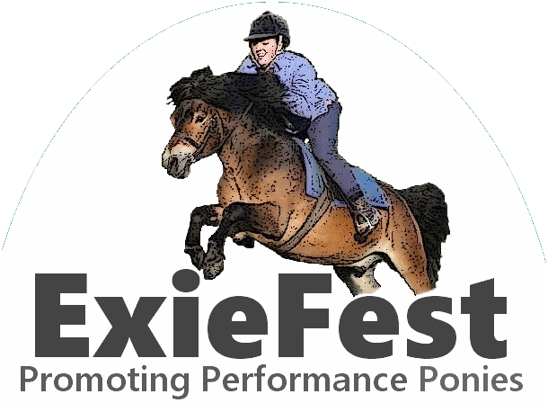
This show has been
kindly supported by:
www.ExieFest.co.uk
www.ShowingScene.com

In-Hand Classes
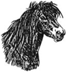
- Filly Foal
Awards to the highest placed Moor Bred and Up Country Bred.
- Colt/Gelding Foal
Awards to the highest placed Moor Bred and Up Country Bred.
Foal Championship
Open to 1st & 2nd Prizewinners of Classes 1 and 2.
Class 3, not to commence before 10:30am.
- Yearling Filly or Colt (born 2023).
Award to the highest placed filly and the highest placed colt.
- 2 Year Old Filly or Colt (born 2022)
Award to the highest placed filly and the highest placed colt.
- 3 Year Old Filly or Colt (born 2021)
Award to the highest placed filly and the highest placed colt.
- Youngstock Gelding (born 2021-2023)
Award to the highest placed yearling.
Youngstock Championship
Open to 1St and 2nd Prizewinners of Classes 3-6.
- Adult Exmoor Ponies In-Hand
Mares, gelding or stallions (handlers of stallions must be over 12 years of age).
LUNCH BREAK – 30 MINS.
During the lunch break, competitors in the ridden classes
can use the indoor school to warm up.
Class 8, not before 12:30pm.
- Condition & Turnout – Ridden or In-hand
Turnout of handlers and riders will be also be judged.
- Young Handlers
Handler to be 14 years and under, to be judged solely on the handing/showing of the pony. No colts or stallions.
Ridden Classes
- Lead Rein or First Ridden
Riders not to have attained their 12th birthday. Mare or Gelding only. Handlers of lead reins must be over 12 years of age.
- Novice Ridden
Ponies not to have won a first prize at any show affiliated to NPS or EPS prior to 1st Jan 2023 or to be in the first season under saddle. Competitors will not canter all altogether. Canter in the individual show is optional.
- Open Ridden
Ridden Championship
Open to 1st and 2nd Prizewinners in Classes 10-12.
SUPREME CHAMPIONSHIP
Open to all champions and reserves
and the 1st & 2nd Prizewinners of Class 7.

THE EXMOOR PONY SOCIETY OFFER Pony of the year qualification and rosette to:- Ridden Champion, Youngstock Champion and Foal Champion. A Marion Williams Award rosette is offered to highest placed rider aged under 25 who is an EPS member. This can pass to the second eligible rider if the first has already been awarded a rosette in 2025.

RULES
This show is open to all ponies registered in Section 1 of the EPS Studbook. Foals that are eligible for registration that have not yet been inspected may also compete.
The Exmoor Pony Society does not accept liability for any loss of property or any accident or damage to any animal, vehicle, spectator or exhibitor, and all entries are accepted subject to this condition. Competitors & owners must have their own third-party public liability insurance.
This show will be run in accordance with the rules of the Exmoor Pony Society. Full details can be found on the EPS website: www.exmoorponysociety.org.uk and a copy will also be available in the show secretary’s office on the day of the show.
Ponies should not be tied to horseboxes and trailers and should never be left unattended.
It is forbidden to ride one pony and lead another or to lead more than one pony at any time.
No child under 16 years of age may compete without an accompanying adult. All lone competitors must report to the Show Secretary and provide an emergency contact name and number.
First aiders can be contacted by the Show Secretary. All accidents & injuries must be reported to the Show Secretary and logged in the accident book.
Dogs must be always kept on short leads.
Please take every possible care and precaution
to always ensure the safety of yourself and others.

