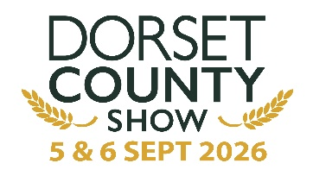
THE NATIONAL BLACKSMITHS COMPETITION
Round 9
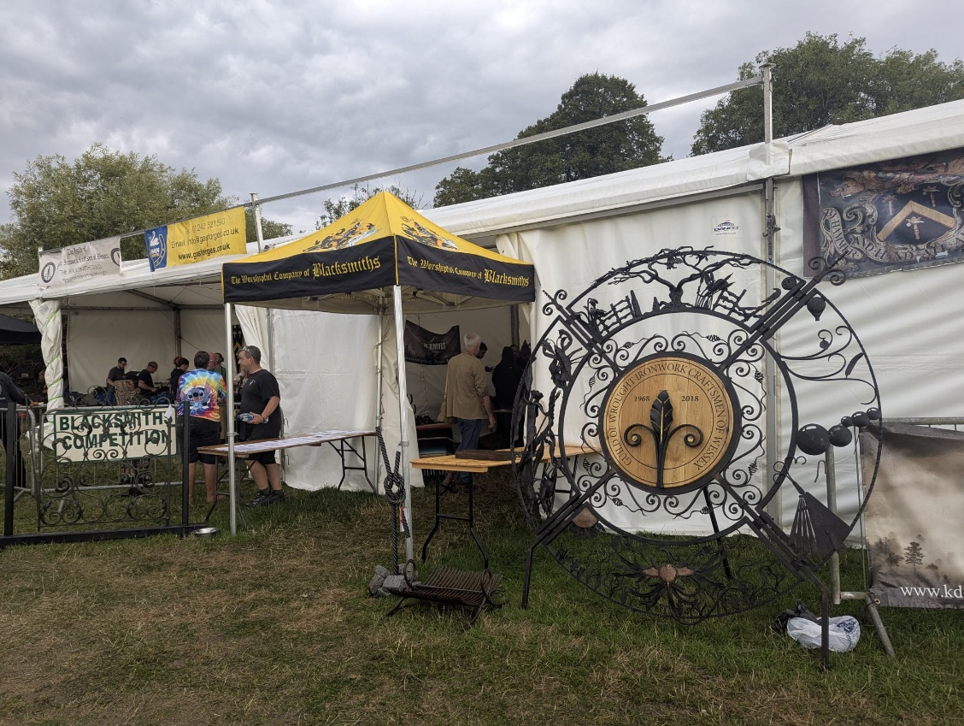
Blacksmiths’ Stand Management - Merv Allen FWCB: 07979 597 431

NBCC Judge – Simon Grant-Jones FWCB LWCB: 07929 571129
Chief Steward - Don Mallett LWCB AWCB: 07907 456 014
Health & Safety Officer - Martin Feeney: 07922 443 569

THANKYOU TO ALL OUR SPONSORS & SUPPORTERS INCLUDING:

The Dorchester Agricultural Society www.dorsetcountyshow.co.uk
The Worshipful Company of Blacksmiths www.blacksmithscompany.co.uk
The Blacksmiths Guild www.blacksmithsguild.com
The National Blacksmith’s Competition www.blacksmithscompetition.com
The British Farriers and Blacksmiths’ Association www.bfba.co.uk
The Eldridge Pope Trust Fund
Simon Grant-Jones FWCB William Murgatroyd

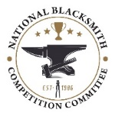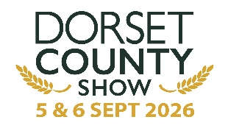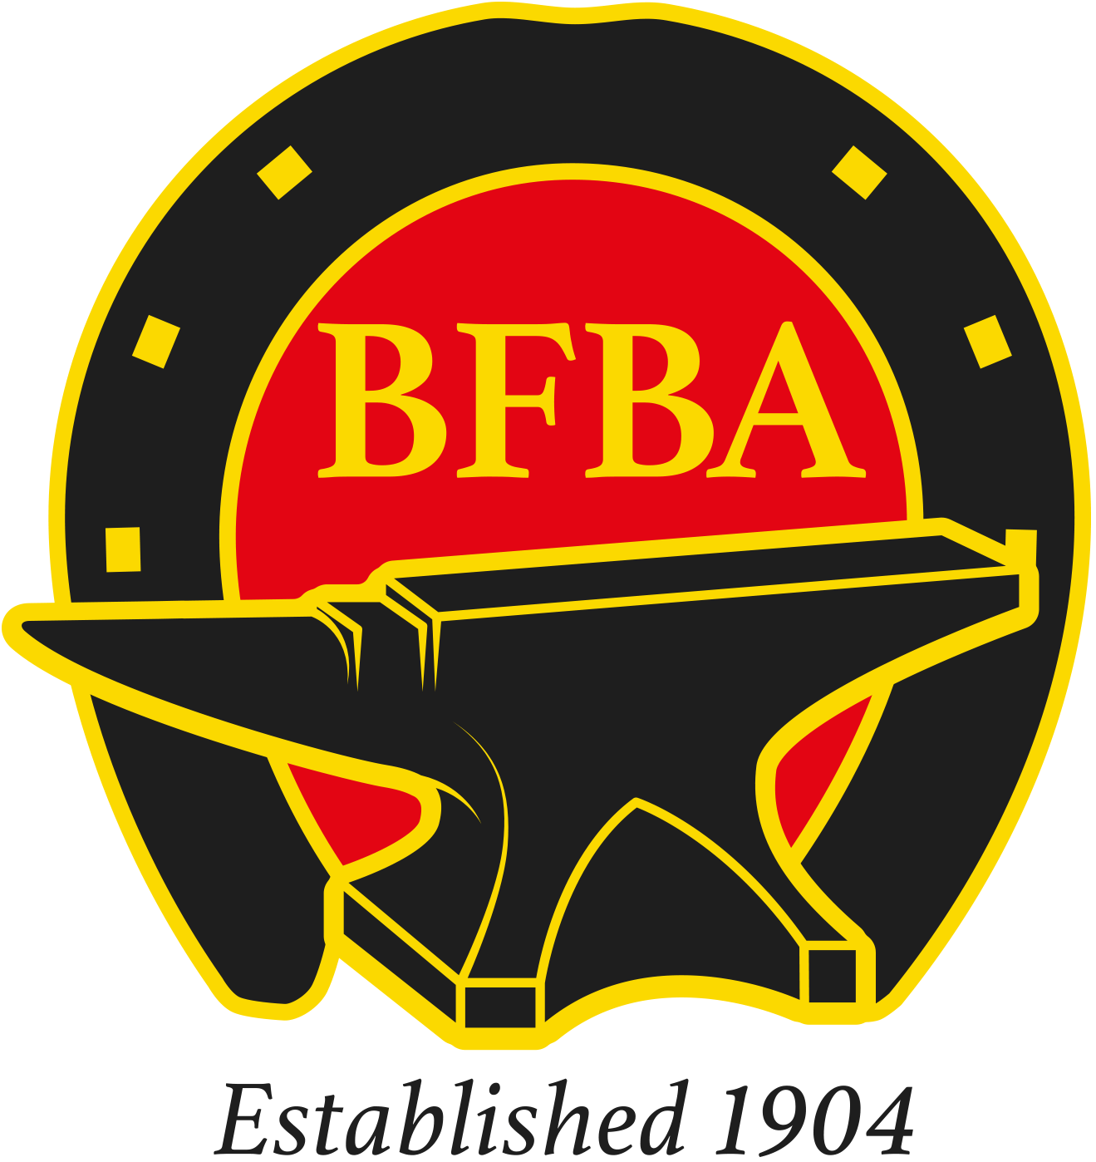

www.blacksmithsguild.com

2 DAYS OF BLACKSMITHING EVENTS INCLUDING:

Round 9 of the National Blacksmiths Competition
www.blacksmithscompetition.com

NBCC entries must be submitted by FRIDAY 21st AUGUST LATEST
via The Dorset County Show website: www.dorsetcountyshow.co.uk
Show Entry Passes are included in the Competition Entry Price Late entrants must pay for their Show Entry Passes

Certificates kindly donated by The Worshipful Company of Blacksmiths www.blacksmithscompany.co.uk

The Blacksmiths’ Guild Live Forging Competitions
Several Classes including those for competitors with less than 3 years’ experience. Entry on the Show days
Details at www.blacksmithsguild.com and Facebook

60 Minute ‘Have-a-Go at Blacksmithing’. One to One Sessions with a Skilled Smith Bookings on the day

Demonstrations of Blacksmithing and Metalworking Techniques

Horseshoe Forging by The British Farriers and Blacksmiths’ Association

Stalls of Forged and Related Craft Items for Sale

Public Vote for a Show Forged Item on Display
Voting slips will be entered into a draw at the end of the Show. The winner to receive a free one-hour introduction to Blacksmithing. The maker of the selected piece will receive a cash prize

THE BLACKSMITHS GUILD AWARDS

THE FRANK DAY MEMORIAL PERPETUAL TROPHY

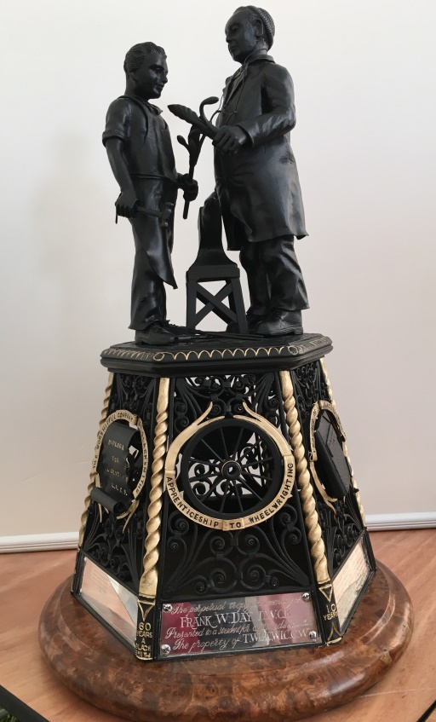
There will be a Frank Day Trophy competition for a static forged item at shows supported by the National Blacksmith Competition Committee. This is in addition to a call for entries to be judged at the Dorset County Show.

The overall winner will be invited to receive the trophy at the Worshipful Company of Blacksmiths Michaelmas Court and Awards Luncheon held in the City of London during October. The award consists of the Frank Day Trophy Award and a cash prize of £250.
The winner's name and year of award will be engraved on the Trophy and displayed at selected venues to promote the Blacksmiths' craft.

This unique trophy was designed and created by the late Robert Hobbs FWCB. Bob was a Master of the Guild, a Worshipful Company of Blacksmiths Liveryman, NBCC Champion Blacksmith and holder of the WCB’s coveted Gold Medal.
The Guild can arrange for the winner to have publicity photos taken with the Trophy for inclusion in their portfolio.
CONDITIONS OF ENTRY
1) Entry is open to all whether they be Guild members or not
2) Candidates must have less than 3 years training or experience
3) Entry is free, and candidates may enter more than one item
4) The candidates name must be printed inside an unmarked envelope securely attached to each item
5) Entries will be judged using NBCC guidelines at the Dorset County Show by a panel of 3 judges who are Blacksmith Guild Committee members. In the event of a tie the Master of the Guild shall make the final decision

THE NATIONAL CHAMPION BLACKSMITHS’ COMPETITION
www.championblacksmith.co.uk
Conditions Governing the Blacksmith of the Year Competitions
- The awards will be given annually.
- The following Shows, authorised by the NBCC, are permitted to hold qualifying heats:
Hereford NBCC Judging Seminar North Somerset Show
Devon County Show Royal Cornwall Show
Royal Three Counties Show Royal Welsh Show
New Forest & Hampshire Show Edenbridge and Oxted Show
Dorset County Show FOCUS 25 at Stoneleigh, Warwickshire
See the NBCC Website www.championblacksmith.co.uk for details
- Shows taking part in the qualifying heats must select at least one Judge from the current official list of accredited Judges issued by the Worshipful Company of Blacksmiths. That Judge will act as the final arbiter of the winners of the qualifying heats for both awards.
- It is mandatory that all entries are made by the registered competitor.
- The marking system and cards issued by the NBCC in conjunction with the Worshipful Company of Blacksmiths must be used by all Judges when assessing competition entries.
- Points will be awarded at each of the authorised shows as follows:-
Winner of Championship = 10 points, Reserve Champion = 4 points
Competitors may enter more than one piece at a show, but all the entries must be judged and marked individually. Marks for several entries cannot be averaged or aggregated.
- The Blacksmith resident in the UK gaining most points in the Static competitions will be declared ‘National Static Champion Blacksmith’. The blacksmith gaining the most points throughout the year in the live forging competitions will be declared ‘National Live Champion Blacksmith’.
- Competitors may enter pieces for more than one show. It is not necessary for the same piece to be entered for each Show, but entries must not have won an NBCC award in previous years.
- In the event of a tie, after all the qualifying shows have taken place, the Blacksmith gaining the highest number of first prizes at the approved Shows will be declared the winner.
- The Champion Blacksmith of the Year (Static and Live) will be awarded a challenge trophy, which they hold for one year and a plaque. The WCB will make equal payments to Static and Live Champions and equal payments to Static and Live Reserve Champions.
The National Static Champion Blacksmith and the National Live Champion Blacksmith of the Year will be presented at the Awards Lunch of the Worshipful Company of Blacksmiths.
The Trophy for the Blacksmith of the Year must be returned to the Clerk of the WCB by 1st October of the year following the one in which the awards are made.
- Organisers of the authorised Shows must return the official form provided by the NBCC giving the names and addresses of the Winner and Reserves of the competitions as soon as possible after the Shows to:-
The Secretary of the NBCC, Mr. Keith Mahoney, 43 The Pound, Bromham, Chippenham, Wiltshire, SN12 2HF.
Photographs of the winning piece in these competitions and of the piece made by the runner up should be sent to the secretary of the NBCC with the forms or as soon as possible after the event.

DORSET COUNTY SHOW 2026

NATIONAL BLACKSMITHS COMPETITION SCHEDULE
www.championblacksmiths.co.uk

Judge: Simon Grant-Jones FWCB LWCB

STATIC CLASSES

CLASS 1: An Indoor or Outdoor Fire Basket
Prizes: 1st £30, 2nd £20, 3rd £10
The first prize winner will be awarded the Leslie Phillips Trophy

CLASS 2: An Item of Kitchenalia (NOT KNIVES)
Prizes: 1st £30, 2nd £20, 3rd £10
The first prize winner will be awarded the Kingston Maurward College Trophy

CLASS 3: An decorative Item suitable for fixing to a House Indoor Wall
Any construction method may be used
Prizes 1st £30, 2nd £20, 3rd £10
The first prize winner will be awarded the Eldridge Pope Trophy

LIVE CLASSES
Note that ‘Strikers’ are not permitted, and time will not be added for ‘Cleaning Up’

CLASS 4: An item produced to the competitor’s design using their own materials
Time allowed 30 minutes
Prizes 1st £25, 2nd £15, 3rd £10

CLASS 5: A Suffolk Latch
Time allowed 90 minutes
Prizes 1st £40, 2nd £20, 3rd £10

WCB Certificates will be awarded to the Static and Live Show Champions and Runners Up together with £240 for the Static and Live Show Champions and £120 for the Runners Up

Entry Fee: £6 Per Item per Class see the National Blacksmithing Competition Entry Form

SHOW REGULATIONS

- It is mandatory that all Static Class entries are made by the competitor
- Judge’s decisions will be final
- Competition entries must not be removed from the showground before 1700hours of the final day
- Every consideration will be taken by the organisers to protect the Competition entries from loss, damage or theft. However, the organisers will not accept responsibility for the items whilst they are in their possession or protection
- The Dorset County Show operates a strict Health and Safety Policy. Correct footwear and eye protection must be worn when live forging. Health and Safety notices will be prominently displayed and Risk Assessments available
- Previous prize winning pieces at the Dorset County Show will not be accepted for entry to the Competitions although any item may be entered free of charge for exhibition or sale in which case the Chief Steward must be notified

Schedule Contact:- Merv Allen, 07979 597431 metalwizard@btinternet.com

DORSET COUNTY SHOW 2026
ENTRY FORM FOR THE NATIONAL BLACKSMITHING WROUGHT IRONWORK COMPETITION www.championblacksmiths.co.uk
Entry Fee: £6 per Item per Class - One Entry for the Live Competitions

NAME: ________________________________________________________
ADDRESS: ________________________________________________________
________________________________________________________
________________________________________________________
PHONE: ________________________________________________________
EMAIL: ________________________________________________________

CLASS | No. OF ENTRIES | DESCRIPTION OF ENTRY | FEE
1 |  |  | £
2 |  |  | £
3 |  |  | £
4 | 1 |  | £
5 | 1 |  | £
 |  | TOTAL FEE | £

Please state preferred day and time for the Live Classes (4 and 5). Note that Live Competitions will end at 1500hours on the Sunday

Saturday AM or PM Sunday AM or PM

Entries may be delivered between 1400 and 1800hours on the Friday before the Show or between 0700 and 0815 on Saturday 5th September Entries received after 0815 will not be judged

Entry forms must be submitted by FRIDAY 21st AUGUST LATEST
via The Dorset County Show’s website www.dorsetcountyshow.co.uk
Show Passes are included in the Competition Entry Price Late entrants must pay for Show passes
Live Class entries can be made on the day subject to the available of time slot

PAYMENT METHODS
BACS: Sort Code 40-51-62 Account 88495803 The Dorchester Agricultural Society
CHEQUE: Payable to The Dorchester Agricultural Society. Please return with this completed Entry Form to:- James Cox, The Dorset Show Office, Agriculture House, Acland Road, Dorchester, DT1 1EF

Competitors with 2 or more entries are allocated 2 x one day tickets and vehicle pass. Extra tickets can be purchased from the Show www.dorsetcountyshow.co.uk Phone 01305 264249

All enquiries: Merv Allen 07979 597431 email metalwizard@btinternet.com

DORSET COUNTY SHOW GROUND COKERS FROME, DORCHESTER Show Office: 01305 264249 What 3 Words: says.ballparks.convey
Blacksmiths Guild courses for beginners and the more experienced are offered at Kingston Maurward College and MOD Lyneham Metalsmiths Training Centre
Full details: www.blacksmithsguild.com or at the Blacksmiths Stand

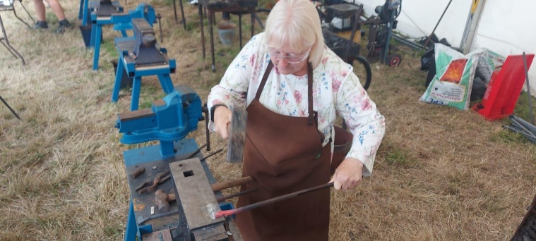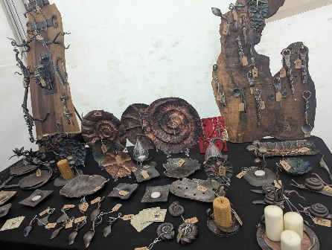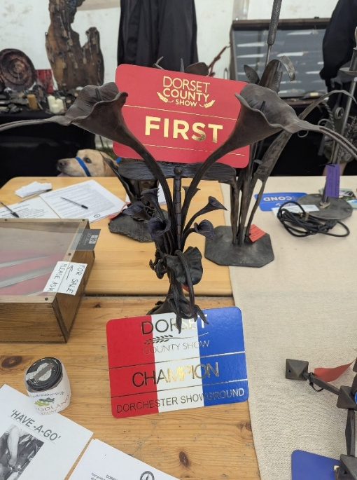
"OLD CLEM" FROM GREAT EXPECTATIONS BY CHARLES DICKENS

Hammer boys round – Old Clem,
With a thump and a sound – Old Clem,
Beat it out, beat it out – Old Clem,
With a cluck for the stout – Old Clem,
Blow the fire, blow the fire – Old Clem,
Roaring drier, soaring higher – Old Clem

A procession used to be held in Chatham on St. Clement's when the Saint was impersonated by a young smith dressed in costume

