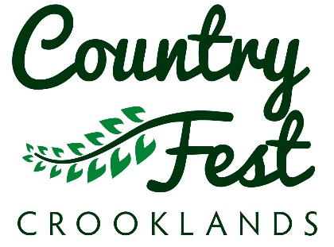

Lane Farm, Crooklands, Milnthorpe, Cumbria LA7 7NH
Telephone 015395 67804
Web: www.westmorlandshow.co.uk
Email: entries@westmorland.org.uk

February 2025

Vintage Exhibition

Country Fest – Saturday 31st May and Sunday 1st June 2025

At Country Fest we aim to celebrate rural life giving a real taste of the countryside. There is a variety of attractions to entertain the visitors from RBST Young Shepherd Event, Sew Crafty, Rabbit, Ferret, Dog and Terrier Shows and colourful Floral design competition marquee, schools challenges, along with many others, a full programme of arena displays, music, dance, trade, craft and food hall and food and drink stalls

Last year we included a vintage tractor exhibition at our Country Fest event which was very well received and enjoyed, so with this in mind we would like to invite you and your vintage vehicle along again for 2025.

Exhibitor Wristbands are valid for both days of the Show and are non-transferable so do state clearly on your application form how many wristbands you need in total. Each vintage exhibitor will be allocated 1 exhibitor wristband and 1 vehicle pass. Exhibitor wristbands are non-refundable and no refunds or replacements will be given in respect of any loss, forgotten or unused admission passes.

All exhibits must be in place by 9.00am each day. Vehicles will not be permitted to move until the Showground is closed to the public (Saturday 5pm; Sunday 4pm at the earliest) and until permission is given by the Chief Steward. Security cover will be on the Showground from Friday evening but please note that all exhibits are left at your own risk.

We do hope you will be with us and look forward to receiving your completed exhibitor application form.

Should you require further information, please do not hesitate to contact the office.

