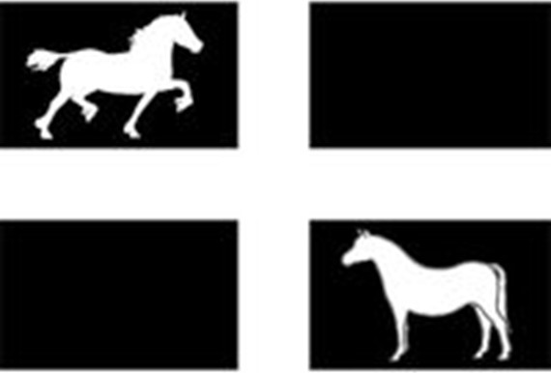
FUN SPRING SHOW
19th April 2026
Knightswood EC
Entry Fees:
Pre entry close – 15th April
CA Members = £10
CA Non Members = £12
First Aid £3

Inhand Classes: 9am Start
Judge:
- Mountain and Moorland Yearling
- Mountain and Moorland 2&3year old
- Mountain and Moorland 4years old and over
- Part bred Welsh/Native Youngstock
- Part bred Welsh/Native 4years old and over
- Open Pony
- Open Horse
Welsh Championship
2 highest placed Welsh A, B, C, D & Welsh PartBred Welsh from classes 1-5
Overall Inhand Championship
1st and 2nd prize winners from classes 1-7
Judge: Miss Kate Lutey – Kensa Stud
- Young handler – Handlers 10years and under, special rosette for the youngest handler
- Junior handler – Handler aged between 11-16years
- Junior Handler – Handler aged between 17-25years
Overall Handler Championship
1st and 2nd prize winners from classes 8-10
Ridden Classes
Judge:
- Novice Combination (Walk & Trot only - cantering optional providing you and your horse/pony are confident)
- Leading Rein
- First Ridden
- Best combination 12-16years
- Best combination 17years and over
- Mountain and Moorland
- Open Pony
- Open Horse
Overall Ridden Championship
1st and 2nd prize winners from classes 11-18
Members Championship
Highest placed CA member from classes 1-18

