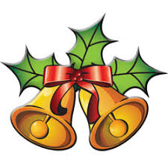
Christmas Party & Awards Evening
Saturday 7th December - 7:00 for 7:30pm
at: Carharrack Sports & Social Club, 2 Chapel Terrace, Carharrack, TR16 5RR
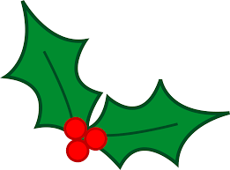
Awards for 2019 Dressage and Jumping Leagues, Seniors and Juniors
Trainers’ Awards
Live Band - One Way Street
Licenced Bar
Pasties and Cakes
Buy tickets through Showing Scene
Members £10:00, non-members £12:00
Under 12s: Members £6:00, non-members £5:00 (smaller cocktail pasties)

