Christmas Fayre

30th November 2:00pm

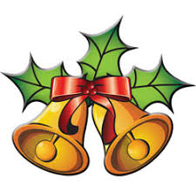
Get your Christmas food, wine and treats

Lots of Lovely Stalls
Set up at 1:00pm
Stalls open 2:00pm
Visitors: £1 entry - raffle ticket prizes
Café open for drinks, food and snacks

