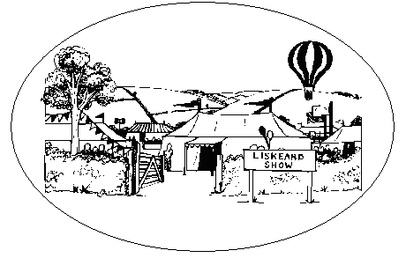
Privacy Notice

Here at the Liskeard and District Agricultural Association (the Data Controller) we take privacy seriously and will only use your personal information for promotional purposes on the Liskeard Show.

Information collected, processed and held
We will hold the following information for you:

Name
Address
Telephone Number
Email address.

The information will be held electronically and stored in the UK in a secure environment

Purpose
We would like to retain this data to provide you with future information for events organised by Liskeard and District Agricultural Society. If you consent to us contacting you, please tick the box on the attached booking form.

Legal Basis
The legal basis for collecting the information is based on consent.

You have the right to withdraw consent for holding your personal data at any time. In order to do so you should contact the show organiser by post or email.

Sharing of information
We will not share your information with any third party.

Retention of data
Data will be retained for a period of three years or until a request is received to delete it.

Right of Individuals
Under the Data Protection legislation you have a right to request access to information we hold on you. To make a request for your personal information contact the show organiser by post or email.

You also have the right to:
- object to processing of personal data that is likely to cause, or is causing, damage or distress
- prevent processing for the purpose of direct marketing
- object to decisions being taken by automated means
- in certain circumstances, have inaccurate personal data rectified, blocked, erased or destroyed; and
- claim compensation for damages caused by a breach of the Data Protection regulations

If you have a concern about the way we are collecting or using your personal data, you should raise your concern with us in the first instance or directly to the Information Commissioner’s Office at https://ico.org.uk/concerns/

Contact
If you would like to discuss any of the information in this privacy notice please contact the show organiser by post or email at the address below.

