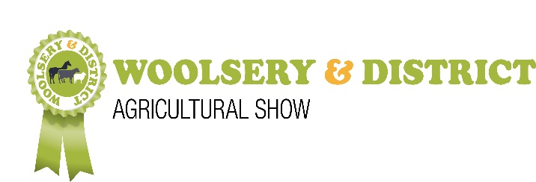
COMPULSORY RISK ASSESSMENT FORM - 2022

THIS FORM MUST BE RETURNED WITH YOUR TRADE STAND APPLICATION
Or upload your own risk assessment.

In order to comply with the statutory regulations of the Health and Safety at Work Act 1974, all exhibitors, displays and stand holders are required to identify fire and any other hazards by completing a compulsory Risk Assessment Form to be returned together with the Trade Stand Application.

The Show’s Health and Safety Risk Advisors must know in advance of any HAZARDS being introduced to the Showground, aiming to pre-empt potential incidents and reduce the risks of accidents. Alternatively, you may send us details of your existing Health and Safety arrangements for attending Show grounds. In particular, the following should be declared and the mitigation measures you will take to minimise risk listed:

HAZARDS – PLEASE CONSIDER ALL POSSIBLE RISKS INCLUDING:
(Complete sections that are applicable to your business)

HAZARD | PERSONS AT RISK | CONTROLS TO MINIMISE
Slipping / Tripping e.g. guy ropes, pegs, trailing cables
Vehicles e.g. tractors, fork lifts, cranes, trucks, vintage vehicles
Vans, cars, motorcycles and quad bikes
Electricity Generators –diesel only, unless approved by the H&S officer
Noise
Hot fluids e.g. refreshments
Display boards, racks and cabinets
Moving parts on machinery

Sharp instruments, blades and sharp edges
Fumes / fuel spillages
Gas, gas cylinders, LPG
Water boilers / Ovens / Hobs
Food safety
Fire Risk e.g. hazardous substances, rubbish & flammable substances
other
other

CONTACT DETAILS (Please complete in BLOCK CAPITALS)
Name of Company, Trade Stand or Individual:
Name of Insurer: | Policy Number:
Signed: email address can be taken as a signature for online entries | Print Name:
Date:

