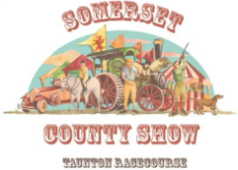
Traders requesting to sell alcohol at the Somerset County Show 2022 Please read and sign this form below:
With regards to the temporary liquor licence that you would normally need to apply for to attend and sell alcohol at a show this will not be necessary which will save you an additional cost.
In order to trade at the Somerset County Show 2022 at the Taunton racecourse we will need you to sign this letter to say you have read and agree to the Taunton racecourse terms and conditions ( please request copy if new trader ) and will comply with these fully. Failure to do so may result in you not being allowed to trade.
We hope this is all acceptable and please agree by signing and dating this letter below to say you have read and agree to these.
Please post or email back to sharon@somersetcountyshow.co.uk when applying for your stand with a copy of your personal liquor licence trading card.
Name: Click or tap here to enter text.

Signed: ……………………………………………………..……………………………………………………………….

Date: Click or tap here to enter text.

