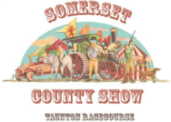
SOMERSET COUNTY SHOW
Saturday 17th and Sunday 18th September 2022
RISK ASSESSMENT FORM
COMPANY:Click or tap here to enter text.
NAME:Click or tap here to enter text.
ADDRESS:Click or tap here to enter text.
TEL No /Mobile :Click or tap here to enter text.
EMAIL ADDRESS:Click or tap here to enter text.
ONSITE CONTACT:Click or tap here to enter text.
You should consider what risk there is to those erecting and dismantling stands as well as to members of the public during the show. Outline the steps you propose to take to minimize that risk.
GROUPS OF PEOPLE WHO MAY BE AFFECTED COULD INCLUDE:
Office staff | Maintenance personnel
Contractors | People sharing your work place
Operators  Members of the public. | Cleaners
PAY PARTICULAR ATTENTION TO:
Staff with disabilities
Visitors
Inexperienced staff
Lone workers
These named above may be more vulnerable
LIST GROUPS OF PEOPLE WHO ARE ESPECIALLY AT RISK FROM THE SIGNIFICANTHAZARDS WHICH YOU HAVE IDENTIFIED AND HOW YOU PROPOSE TO MINIMISE THE RISKS ASSOCIATED TO THEM. Attach more information if necessary.

Click or tap here to enter text.

