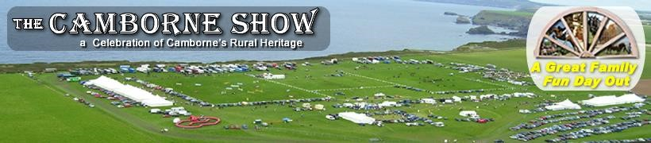

CAMBORNE HORSE SHOW
Saturday 21st July
Miniature Horse & Shetland Section
Open To All Miniature Horses, Standard & Miniature Shetlands
Camborne Show
Gwealavellan Farm
Nr Coombe
Camborne
Cornwall
TR27 5EF

Miniature horse Secretary
Kim Johns
Sunnyside
Higher Pengegon
Camborne
Cornwall
TR14 7UA
07854044584
minihorse@camborne-show.org.uk

DOUBLE QUALIFING SHOW!
IMHPS MHCGB

IMHPS MHOYS QUALIFIER
1st, 2nd and 3rd in each class are qualified for the 2018 Miniature Horse of the Year Show. All exhibits must be registered with the
IMHPS and are to be owned by current members of the IMHPS. Horses must not exceed 38".
MHOYS will take place on September 29 at Onley Grounds Equestrian Complex, Willoughby, Rugby, Warwickshire CV23 8AJ.

MHCGB CHAMPIONSHIP SHOW QUALIFIER
1st – 3rd placed horses qualify for MHCGB grand championship show to be held at Oakridge Arena near Newark. All exhibits must be registered with the MHCGB and are to be owned by current members of the MHCGB. Horses must not exceed 38”

GEMS (Group Established for Miniature Shetlands)
The Miniature Shetland classes will be affiliated with GEMS

SPSBS
The show will be affiliated with the British Spotted Pony Society

Judge; Mr O Roberts - Ireland

Class entries £5.50 pre entries or £6 on the day
PRE-ENTRIES can be taken on SHOWING SCENE for £5.50 pre entries close on the 19th July at 9pm. Entries on the day welcome from 8am.

MINIATURE HORSE SECTION

Miniature Horse Ring 9:00am Start

CLASS 1
Yearling, colt, filly or gelding
Sponsored by TREWEATH ENGINEERING

CLASS 2
- year old, colt, filly or gelding
Sponsored by HARTS HAULAGE

CLASS 3
- year old, colt, filly or gelding
Sponsored by CARHARRACK FEED STORES

CLASS 4
Open to 4 years and over Mare and gelding.
Sponsored by RUGGLES EQUESTRIAN

CLASS 5
Open to 4 years and over stallions.
Sponsored by EQUINE BRIDLE DISCS
Stallion Discs and rosette kindly donated for 1st place winner

MINIATURE HORSE SECTION CHAMPIONSHIP
Open to all 1st & 2nd winners
Prizes kindly sponsored and donated by BOTANICA INTERNATIONAL

The following classes are open to all Ages

CLASS 6
Solid colour
Sponsored by KENWYN VETS

CLASS 7
Broken coloured
SPONSORED BY HORZE HOODS

Class 8
Spotted horses
Sponsored by RUGGLES EQUESTRIAN

CLASS 9
Scaled down show hack
Sponsored by H.C SHOW PRODUCTION

CLASS 10
Scaled down hunter
Sponsored by THE FOUR LEAVED CLOVER STUD

CLASS 11a
Open to registered British spotted ponies under 42”
1,2,3 year old colt, filly and geldings
Sponsored by BILL BANISTER EST AGENTS

CLASS 11b
Open to registered British spotted ponies under 42” 4 years and over stallion, gelding and mares.
Sponsored by BILL BANISTER EST AGENTS

MINIATURE HORSE SECTION CHAMPIONSHIP
Open to all 1st & 2nd winners
Sponsored by CARHARRACK FEED STORES

OVERALL SUPREME MINIATURE HORSE CHAMPIONSHIP
Open to all champions and reserve champions Sponsored by EASTERN DESIGNS HORSE TACK.

JUDGES LUNCH BREAK
STANDARD SHETLAND SECTION not before 1pm

MINIATURE HORSE RING not before 1pm
Class 12
Yearling, colt, filly or gelding
Sponsored by KENWYN VETS

Class 13
2&3 year old colt, filly or gelding
Sponsored by SUPERIOR SHOWING ATTIRE

Class 14
4 years and over mares and geldings
Sponsored by ROWEN BARBARY HORSE FEEDS

Class 15
4 years and over stallions
SPONSORED BY EQUINE BRIDLE DISCS
Stallion Discs and rosette kindly donated for 1st place winner

The following classes are open to any age standard Shetlands

CLASS 16
Solid colour
Sponsored by R and J GENERAL BUILDERS

CLASS 17
Broken coloured
Sponsored by DUCHY BANDED WHEELS

STANDARD SHETLAND CHAMPIONSHIP Open to all 1st & 2nd winners
Sponsored by THE NATIVE PONY SADDLE COMPANY.

MINIATURE SHETLAND SECTION

Class 18
Yearling, colt, filly or gelding
Sponsored by TREWEATH ENGINEERING

Class 19
2&3 year old colt, filly or gelding
Sponsored by C R DRESSAGE

Class 20
4 years and over mares and geldings
Kindly sponsored by TRESUVI SHETLANDS

Class 21
4 years and over stallions
SPONSORED BY EQUINE BRIDLE DISCS
Stallion Discs and rosette kindly donated for 1st place winner

The following classes are open to any age Miniature Shetland’s

CLASS 22
Solid colour
Sponsored by EASI BED BEDDING

CLASS 23
Broken coloured
Sponsored by DUCHY BANDED WHEELS
CLASS 24
Ridden Shetland
Open to horses 4 years and over mare & geldings
Sponsored by Hairy Horse Services

MINIATURE SHETLAND CHAMPIONSHIP
Open to all 1st & 2nd winners
Sponsored by CALLESTICK FARM

OVERALL SUPREME STANDARD AND MINITURE SHETLAND CHAMPIONSHIP
Open to all champions and reserve champions from Standard & Miniature
Shetland sections. Sponsored by TINA PALMER

A MASSIVE THANK YOU TO OUR 2018 SPONSORS
WITHOUT YOUR SUPPORT THIS SHOW CANNOT RUN
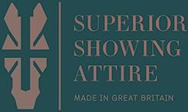
Class Sponsors;
- Treweath Engineering www.treweath.com
- Harts Haulage www.hartshaulage.co.uk
- Carharrack animal feeds cornwallfeedstore.com
- Ruggles Equestrian www.ruggles-horse-rugs.co.uk
- Equine Bridle Discs www.equinebridlediscs.co.uk
- Horze Hoods www.horzehoods.com
- H.C Show Production
- The Four Leaved Clover Stud
- Bill Banister Estate Agent
- Superior Showing Attire www.superiorshowing.com
- C R Dressage 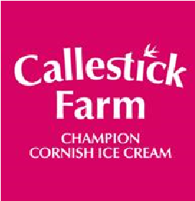
- Tresuvi Shetlands
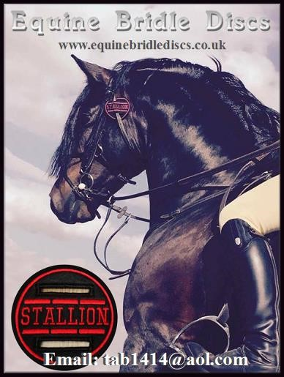
- Oil 2 Horse
- Kenwynn vets
- Rowen Barbary Horse Feeds
- R and J General Builders 07813367348
- Duchy Banded Wheels & Powdercoatings

Championship Sponsors; ❖ Botanica International https://www.botanica.ie

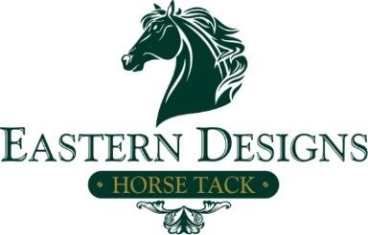
- Native Pony Saddle Company www.thenativeponysaddlecompany.com
❖

Callestic Farm

❖

Carharrack Animal Feeds

Supreme Championship Sponsors

❖

Tina
Palmer

❖

Eastern Designs Horse Tack

http://easterndesignshorsetackshop.co
m

CLASS
NUMBER/s

NAME OF HORSE

NAME OF OWNER

ENTRY FEE
£6 PER
CLASS

TOTAL ENTRY FEES £__________

