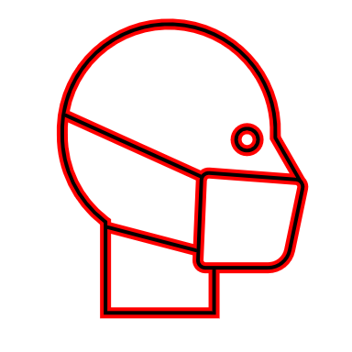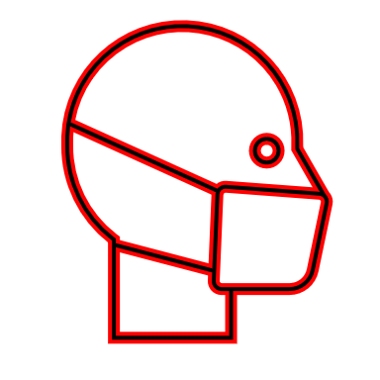**COVID TRACK & TRACE FORM MUST BE FILLED OUT TO GET ACCESS TO SHOWGROUND**

*NO FORM NO ENTRY*

* MASKS MUST BE WORN AT ALL TIMES WHEN OUTSIDE OF THE RING BY ALL PEOPLE ON THE GROUND.
* ALL BUBBLES ATTENDING THE SHOW MUST FILL OUT THE COVID’19 TRACK AND TRACK FORM. THIS MUST BE FILLED OUT BEFORE ATTENDING THE SHOW TO GET ACCESS TO THE SHOWGROUND.
  + **TO GET ACCESS ON TO THE SHOWGROUND** ALL BUBBLES when coming through the gates must give this form to the attending person on the gate. This person will be wearing a HI VIZ SWA of WPCS vest.
  + Preferably only 3 people per horsebox including riders, owners/exhibitors and grooms. However, if there is a need for you to bring more, please make sure that person comes from your personal Bubble and is included on the form.
* Anytime that you may have to queue please only have one person queueing from your bubble. i.e. for food or for the secretary tent.
* All spectators must be wearing masks.
* Please use the hand sanitisers BEFORE and AFTER entering the SECRETARY’S TENT.
* ******ANYONE NOT OBEYING THESE RULES MAY BE ASKED TO LEAVE THE SHOWGROUND.**

**REMEMBER TO SCAN OUR THE NHS COVID 19 QR CODE**

|  |  |  |
| --- | --- | --- |
| **WPCS Kernow Show Track & Trace Form** | | **No.(for office)** |
| **Lorry/Car & Trailer/ Van/ Car *(Circle correctly)*** | **Vehicle Registration:** | **Date: 27/06/2021**  **Time of arrival:** |

Please fill out this form full for all people in the vehicle entering the showground. Please either cross out or explain each person’s (except the driver) reason for being on the showground. Thank you for your time and consideration. We hope you have an enjoyable day.

|  |  |  |  |  |  |
| --- | --- | --- | --- | --- | --- |
| **Driver Full Name:** |  | **Telephone:** |  | **Mobile:** |  |
| **2nd Person Full Name:**  **(Circle appropriately)**  **Rider/Groom/Owner/Other……………………** | | **Address:** |  | | |
|  | | | |
| **3rd Person Full Name:**  **Rider/Groom/Owner/Other……………………** | | **E-Mail** | | | |
| **I Have:** Pre-Entered/ Pre-Entered but also entering on the day/ I am Entering on the day **(Circle appropriately)** | | | |
| **4th Person Full Name:**  **Rider/Groom/Owner/Other……………………** | | I can confirm that none of us have had a cough, fever, loss of smell, temperature or :-   * Live in same household as another person who has COVID-19 symptoms or has tested positive for COVID-19 * Non of us have had any of the following types of contact with someone who has tested positive for COVID-19: * face-to-face contact including being coughed on or having a face-to-face conversation within one metre * been within one metre for one minute or longer without face-to-face contact * been within 2 metres of someone for more than 15 minutes (either as a one-off contact, or added up together over one day * Been in contact with anyone who has tested positive for COVID 19 in the last 10 days.   Sign……………………………………… Print……………………………………….. | | | |
| **5th Person Full Name:**  **Rider/Groom/Owner/Other…………………..** | |
| **6th Person Full Name:**  **Rider/Groom/Owner/Other………..** | |

