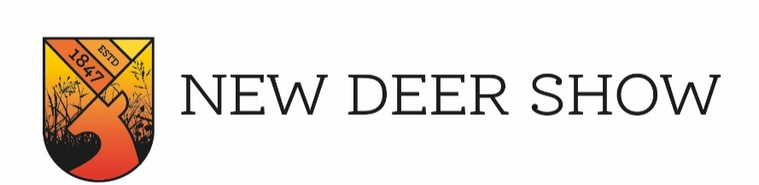
New Deer Show – Risk Assessment Form
In order to comply with the statutory regulations of the Health and Safety at Work Act 1974, all Exhibitors, Displays and Stand Holders are required to complete a Risk Assessment Form to be returned together with the Stand Application. Alternatively, you may send us details of your existing Health and Safety Arrangements for attending Show Grounds. In particular the following should be declared:-
HAZARDS: PLEASE CONSIDER ALL POSSIBLE RISKS INCLUDING:
Slipping/Tripping e.g. Guide, Guy Ropes and pegs | Sharp Instruments, Blades & Sharp Edges
Vehicles: e.g. Tractors, Fork Lifts, Trucks | Fumes/Fuel Spillage’s
Vans, Cars, Motor Cycles & Quad Bikes | Water Boilers/Ovens/Hobs
Electricity Generators | Gas, Gas Cylinders, LPG
Hot Fluids e.g. Refreshments | Fire Risks e.g. Rubbish & Flammable Substances
Display Boards, Racks and Cabinets | Moving Parts on Machinery

HAZARDS | PERSONS AT RISK | CONTROLS TO MINIMISE RISK

FIRE RISK ASSESSMENT
HAZARDS | PERSONS AT RISK | CONTROLS TO MINIMISE RISK

TRADE NAME

ADDRESS

POSTCODE

PUBLIC LIABILITY INSURANCE POLICY NO.

INSURERS

EXPIRY DATE
ASSESSED BY
SIGNATURE

If you think there are no significant risks relating to your stand please state “no risk” and sign form.

