
MOBILE HAND WASHING – QUESTIONNAIRE

ALL CATERING UNITS (COOKING AND NON COOKING) ARE REQUIRED TO COMPLETE THE ATTACHED FORM, AS RQUESTED BY WEST LINDSEY DISTRICT COUNCIL ENVIRONMENTAL HEALTH OFFICERS.
PLEASE RETURN Friday 31st October TO:
THE TRADE TEAM, LINCOLNSHIRE SHOWGROUND, GRANGE DE LINGS, LINCOLN LN2 2NA

COMPANY NAME: ………………………………………………………………………

STAND NUMBER: ………………………………………………………………………
(office to complete this if unknown)

NAME OF CONTACT ON STAND: ………………………………………………………..…..

MOBILE NUMBER: ………………………………………………………………………

SIGNED/DATED: ………………………………………………………………………

Safe method – To be completed and kept on site during the Show  MOBILE HAND WASHING FACILITIES  Effective hand washing is essential to help prevent  bacteria spreading to food | 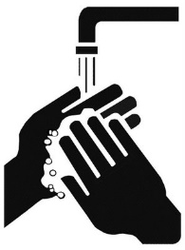

Safety Point | Why? | How do you do this?
If you handle open ready-to-eat foods you must provide a wash hand basin in an accessible position.  This facility must be fully operational prior to commencing food handling activities. | Hand washing facilities must be provided in order to control the spread of dangerous bacteria. Being accessible makes the facilities easier to use.  As you must have hand washing facilities, these must be set up before you start trading so that food handlers may wash their hands. | Where are your washing facilities located whilst trading?
The wash basin must be provided with an adequate supply of running hot and cold water or mixed water, anti-bacterial soap and a means of hand drying (see Additional Requirements for cleaning materials).  The hot and cold water or mixed hot water must be delivered to the basin directly by means of a tap, water pump etc.  The use of a bowl/bucket filled with hot water from a kettle or likewise will not be an acceptable provision for hygienic hand washing. | Hot water and anti-bacterial soap are essential for the control of dangerous bacteria, so there must be enough hot running water and soap for food handlers to wash their hands throughout the day.  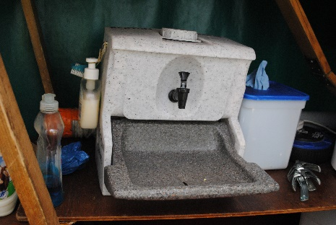  Kettles, flasks or jugs etc to mix hot and cold water are NOT ACCEPTABLE.  The water quickly becomes cold and dirty.  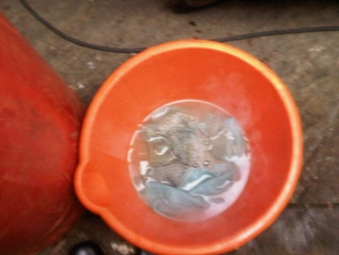 | List what you use:  How is your hot and cold water dispensed into a basin?
You will be required to achieve the above by providing either:  - A direct supply of hot water to a fixed wash hand basin by an instantaneous water heater (“Burco”, “Paloma”, gas or electric or similar) and a piped cold water supply (hand, foot pumped or electric pumped) from a container to a wash hand basin.  Water heaters and “Burco” boilers should be sited so that they deliver a stream of running water directly into the basin.  Water heaters must be of sufficient capacity to provide a constant supply of hot and cold potable water.  Or,  - An insulated container of hot water providing a direct piped supply to the fixed wash hand basin. The insulated container must be of suitable capacity and capable of holding the water at a hot enough temperature for hand washing. | This allows for water to be thermostatically controlled or mixed to a temperature that hands can safely be immersed in for hand washing.  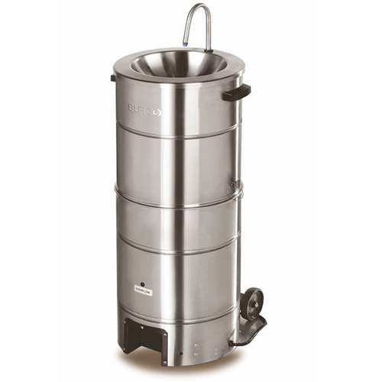  The basin allows for you to wash your hands more effectively.  As you must have an adequate supply of hot or mixed water, the heaters used must have enough capacity to meet this.  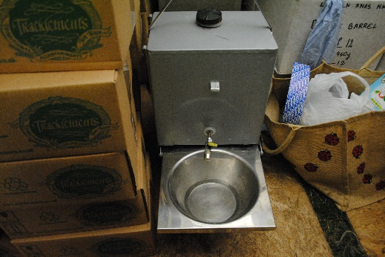 | How do you heat your water?  How do you mix hot and cold water?  How do you make sure that enough water is available for food handlers to wash their hands throughout the day?  Do you use an insulated container to provide your hot water?
Additional requirements
The use of disposable gloves, tongs or antibacterial hand gels/wipes does not remove the requirement for you to provide hand washing facilities. | Gels/wipes are not as effective as hand washing for removing bacteria from your hands but are good to use in addition to washing hands. | Which of these do you use?
A wash hand basin must be provided with drainage direct into a sealed container.  Waste water should not be poured onto the ground. | This is so that you have somewhere secure for your waste water until it can be disposed of appropriately. | How do you dispose of your waste water?
Cleaning Materials  The wash hand basin must have liquid soap that meets BS EN 1499:1977.  The wash hand basin must have paper towels.  Ensure that you have adequate supplies of paper towels at all times.  A bin for the paper towels must be provided near to the wash hand basin. It is safest if paper can be thrown in the bin without touching the bin (e.g. a pedal bin that is foot operated to lift the lid). | This standard has been proven to kill bacteria.  Single use towels are safest because hands that are clean after washing can be re-contaminated by touching a dirty hand towel.  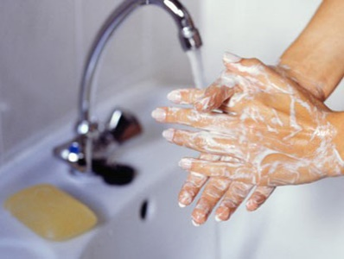  If staff have to touch the bin they may re-contaminate their hands. | Are the wash basins in your business supplied with liquid soap BS EN 1499:1977?  Yes No  Do you provide paper towels?  Yes No  If not, how do you make sure hand drying is hygienic?  What bins do you have?

