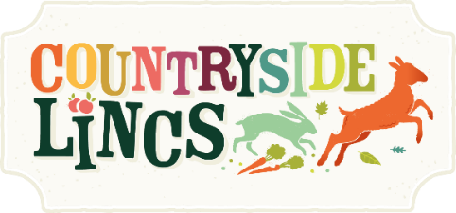

Alcohol Sales Application Form
- You must complete this form if you’re selling any products containing alcohol as you will operate under our premises licences.
- All exhibitors will be visited by our DPS on Sunday 6 April to ensure the correct paperwork is in place and that all appropriate signage is being displayed.
- No alcohol may be sold at the event, without the presence of one of the named personal licence holders listed on this form.

Contact and Product Details
Company Name:

Trading Name (if different):

Telephone: | Email:
Description of licensable product e.g. sale of bottled cider:

Details of nominated personal licence holder(s) on site at all times (continue on separate sheet if necessary)
Title: | First Name:
Surname: | License No:
Issuing authority (e.g. West Lindsey District Council):
Details of all staff selling alcohol during the event (continue on separate sheet if necessary):
First name: | Surname:
First name: | Surname:

I confirm that the above information is correct and that if any of these details change, I will contact the Lincolnshire Agricultural Society at the earliest opportunity on 01522 522900. I confirm that all staff on the trade stand will operate within the ‘Challenge 25’ policy and will not provide alcohol or alcohol-based products to anyone under the age of 18.
Please complete and return this application form to the below address by 6 March.
The Trade Team, Lincolnshire Agricultural Society, Lincolnshire Showground, Grange-de-Lings, Lincoln LN2 2NA or email trade@lincolnshireshowground.co.uk
- A £25 (£30 inc VAT) License Administration Fee will have been added to your original booking.
- A sales pack, including your authorisation to sell, will be issued during set-up of Countryside Lincs.
- Failure to comply with the Licensing Act 2003 will result in your trade stand being closed.

Signed:
Print: | Date:

