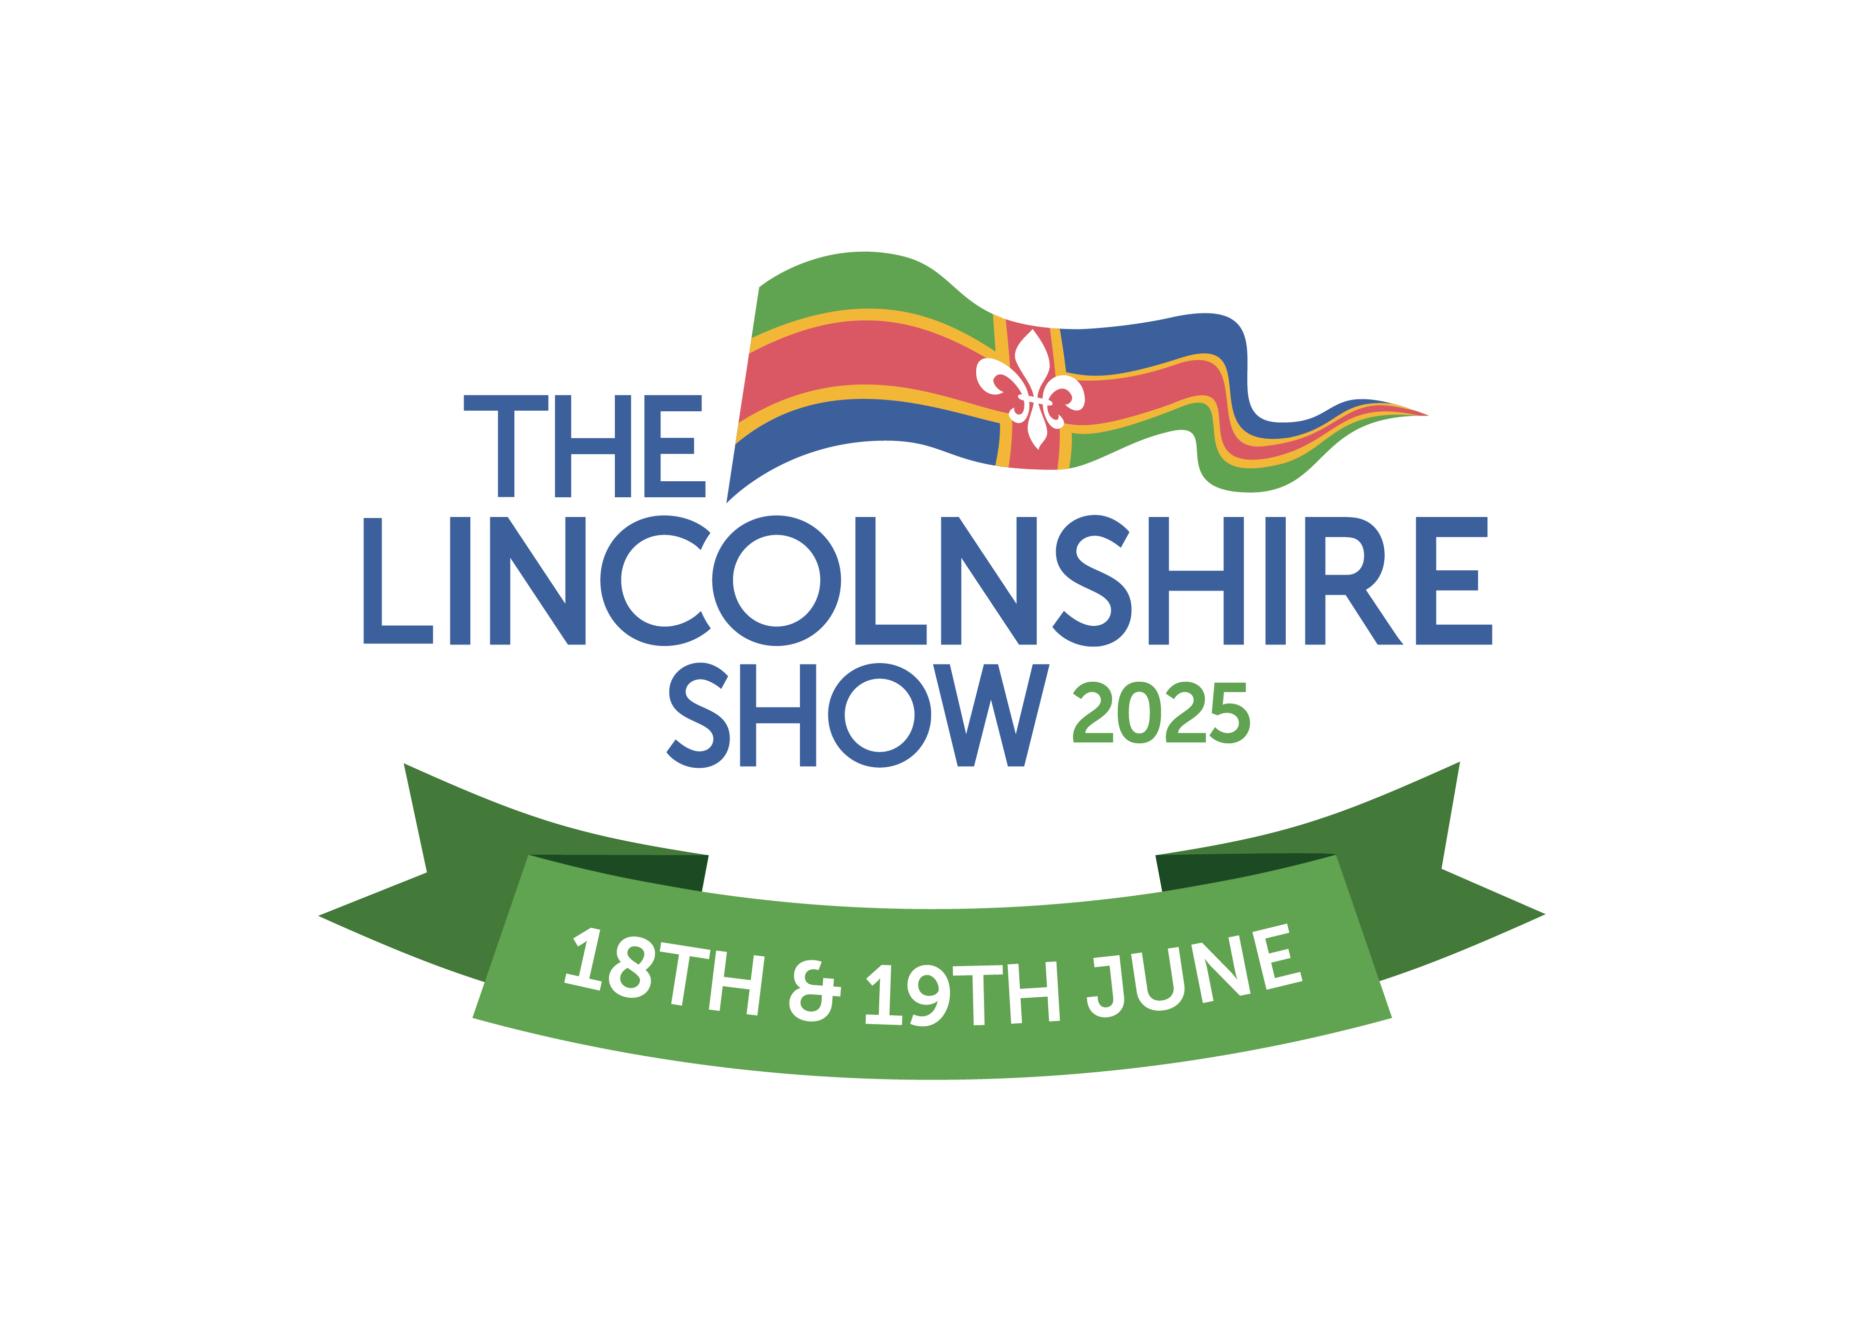
Alcohol Sales
Application Form

You must complete this side of the form if you’re selling alcohol
or alcohol based products (falling under licensing legislation).
Complete the alcohol hospitality form if your trade stand is providing free alcohol.

- All traders in this category will be visited on their stands on Tuesday 17th June 2025 by our Licencing and Compliance team.
- Exhibitors must agree to operate within the ‘Challenge 25’ policy and ensure that no alcohol is served to anyone under the age of 18 years. The Licencing and Compliance team will inspect stands to ensure that the appropriate signage, etc is being displayed.
- No alcohol may be sold from any stand without the presence of one of the named Personal Licence Holders listed below being present.

Company Name |  |  | Trading Name  (if different)
Description of licensable product
e.g. sale of bottled cider
Details of nominated Personal Licence Holder(s) on site at all times (continue on a separate sheet if necessary):
1. Title |  |  | 1. First name
1. Surname |  |  | 1. Licence No.
1. Issuing Authority |  | e.g. West Lindsey District Council
2. Title |  |  | 2. First name
2. Surname |  |  | 2. Licence No.
2. Issuing Authority |  | e.g. West Lindsey District Council
Details of all staff selling alcohol during the Show (continue on a separate sheet if necessary):
First name |  |  | Surname
First name |  |  | Surname
First name |  |  | Surname
First name |  |  | Surname
First name |  |  | Surname
I confirm that the above information is correct and that if any of these details change, I will contact LAS at the earliest opportunity, telephone 01522 522900:

Name |  |  | Signed
Email address |  |  | Telephone

- Complete this form and return it to Lincolnshire Agricultural Society by 31st May 2025.
- Ensure a £36 inc. vat Licence Administration Fee has been paid with your application.
3. Authorisation to sell information will be given to you by our licencing officer on Tuesday 17th June.

