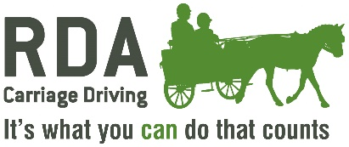
ATTENDING AN EXTERNAL EVENT - CARRIAGE DRIVING

GROUP INFORMATION
Group/Region:
Group Driving Organiser:
Contact No.
Email Address:
Regional Driving Rep:
Date:
EVENT INFORMATION
Event Name and Description:
Date of Event:
Address and Postcode of Venue:
Name of Event Organiser:
Event Organiser Contact Number:
Please confirm that you have had sight of Public Liability Insurance Certificate for this event – YES/NO –
How much cover is on the certificate? (Minimum £5 million):
Name of Qualified RDA CD Coach or Coaches attending the Event:
Do you have enough suitably Qualified Green-Carded Volunteers to attend?
NAMES OF COMBINATIONS OF DRIVERS, RDA COACHES, AND EQUINES
ATTENDING THIS EVENT.

Name of Driver | Name of RDA CD Coach | Name of Equine

CERTIFICATE OF COMPETENCE
FOR EXTERNAL EVENTS

TO BE COMPLETED BY EACH CD COACH with Competency column filled in by Reg. Dr. Rep.

Name of RDA CD Coach | Signature of CD Coach | Competent (√ or x)  (Reg. Dr. Rep. to fill in)
Event Name and Description:
Date of Event:

TO BE COMPLETED by the REGIONAL DRIVING REP.

I CONFIRM THAT THE INDIVIDUAL(S) NAMED ABOVE IS/ARE COMPETENT TO COACH AT THE EVENT DETAILED ABOVE AS AN RDA CD COACH.

Name of Reg. Dr. Rep:

Signed:

Date :

When completed please email this form to NATIONAL OFFICE
(coaching@rda.org.uk )
and copy to your Regional Carriage Driving Representative.
Please retain a copy for the Group.

