Creating an account / Logging In
First go to https://showingscene.com/
Then click Log In /Register in the top right corner. 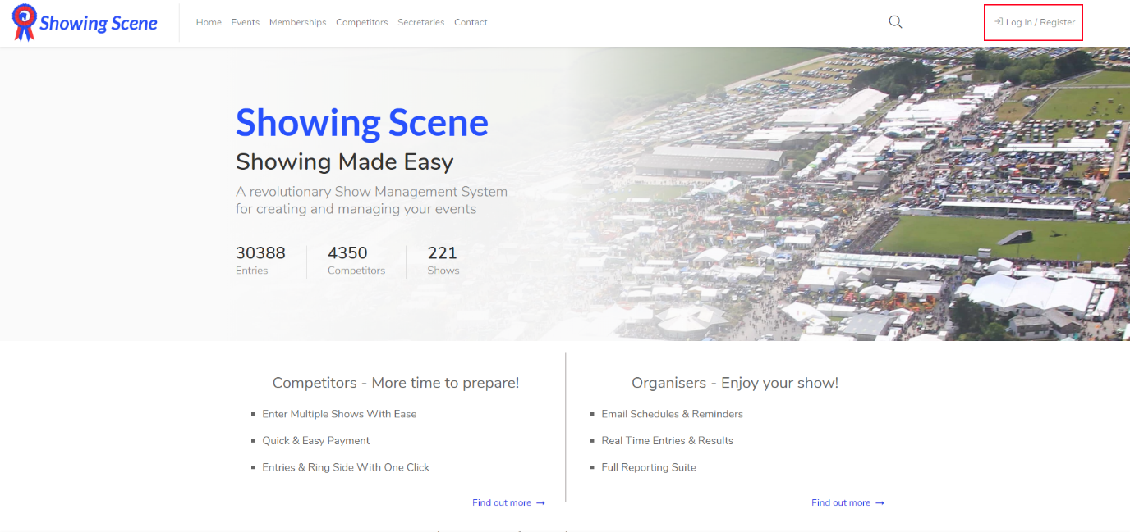
Figure 1: Showingscene.com home screen
A window will pop up asking for you login details. If you already have an account, please enter them and click login. If you need to create an account, please click Register at the top of the window.
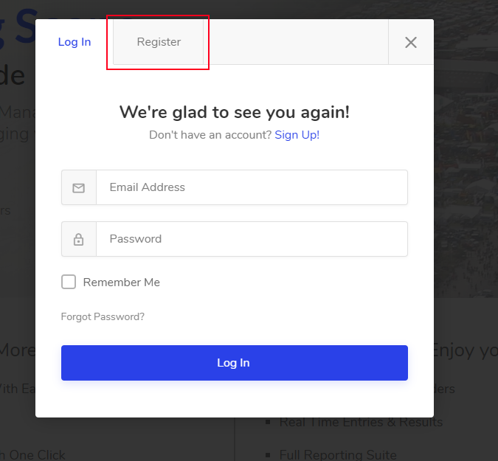
Figure 2: Login window that pops up

The window will now expand and show you more fields. Please fill out the form and then select ‘Register’ at the bottom.
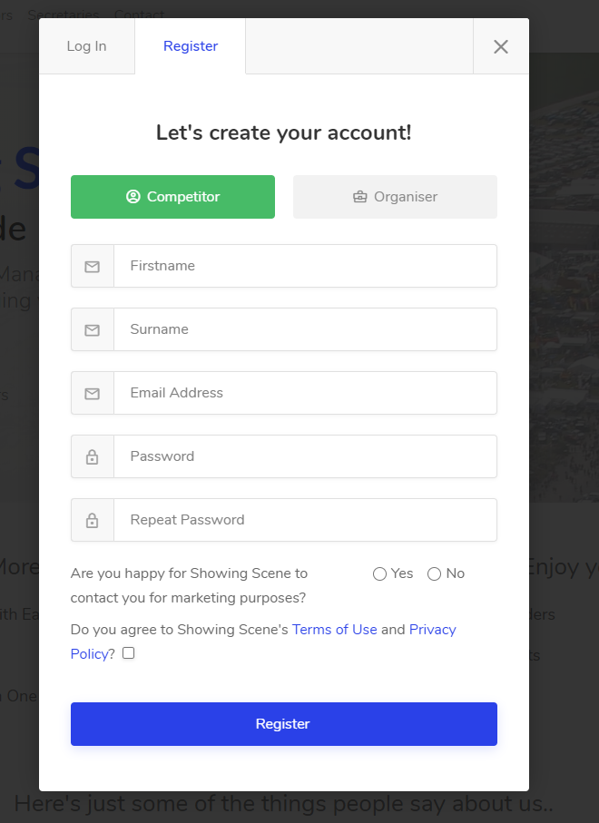
Figure 3: Registration Form

Now you’ve created an account you will automatically be logged in.

Logging out
Once you’ve finished judging you can either select the avatar in the top right corner and select Logout or you can select Logout from the navigation panel on the left.
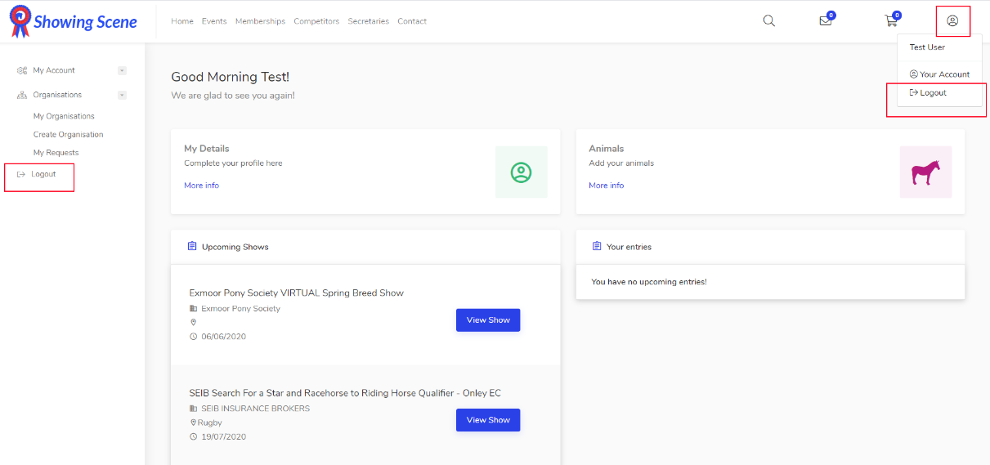
Figure 8: Logging out

