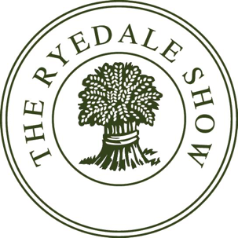
HORSES AND PONIES SECTION Timetable 2024
Please Note:
Times for classes are an approximate guide only. Classes will not start before the time stated in the Schedule.

Rings could be changed to help secure the smooth running of the show. Announcements will be made during the day.

*** RYEDALE SHOW RESERVE THE RIGHT TO AMALGAMATE OR CANCEL CLASSES IF ENTRIES ARE EXTREMELY LOW ***

Ring 2
9am – Small Breed Mountain & Moorland In Hand, followed by Championship followed by Large Breed Mountain & Moorland In Hand, followed by Championship and Supreme Large & Small Championship.
12 noon – Cleveland Bays, Followed by Championship

At 12.30pm - Rings 1 and Ring 2 will amalgamate to become the Main Ring

1230 - Lamb National
1310 - Best Decorated Heavy Horse
1330 - Parade of Vintage Tractors
1400 - Mounted Fancy Dress
1420 - Heavy Horse in Plough Harness
1440 - Lamb National
1515 - Grand Parade of Heavy Horse and Cattle Prize winners
1550 - Parade of Sinnington Hounds
1610 - Heavy Horse Turnout Class
1640 - Children's Races

Ring 3A/ B
9am - Hunter Breeding followed by Championships.
10.15am - In Hand Irish Draught
11:30am - Heavy Horse Young Handler. Followed by Shires & Clydesdales, judged at separate ends of the ring. Shire and Clydesdale Championships followed by Supreme Heavy Horse Championship
1pm - In Hand Coloureds, followed by Championship followed By Ridden Coloureds and Championship
3pm - Veteran Classes

Ring 4
9am – Ridden Show Pony, followed by Championship.
11am - RiddenShow Hunter Pony, followed by Championship.
12 noon - Ridden Mountain and Moorland

Ring 5
9am – Ridden Hunters, followed by Championship.
1.15pm – Ridden Irish Draught
2.30pm - Driving Classes

Ring 6
10am – Working Hunter Pony, followed by Championship.
11.00am – Working Hunter Classes.
2pm - Mountain & Moorland Working Hunter Pony, followed by Championship

Ring 7
9.00am – Ridden Cobs followed by Championship.

10.30am – Riding Horse
11.30am – Novice Retrained Racehorse Class.
Followed by - Open Retrained Racehorse Class.

Ring 8
8.30am – Dubarry Burghley Young Event Horse Classes

2.00pm - Open Retrained Racehorse Class.

Unaffiliated Show Jumping will follow the Open Retrained Racehorse class . They will be run by Alison Brown , Friars Hill Stables .Tel 01751 432758

Entry form can be found in additional documents.

