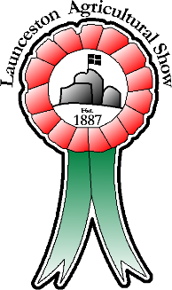
Launceston Agricultural Show

Health and Safety Risk Assessment
25th July 2024

You should consider what risk there is to those erecting and dismantling stands, sales staff and members of the public during the Show.
Please outline the steps you propose to take to minimise those risks. Nearly every stand will have risks associated with manual handling and trip hazards and these should be assessed.
Look only for hazards that you could reasonably expect to result in significant harm in your workplace at the show. Assess the severity of risk as High/Medum/Low.
Typical Hazards | Who could get harmed and how? | Severity of Risk:  High/Medium/Low | Controls taken to minimise risk
Trips and slip

Manual Handling/Lifting

Blades/sharp objects/broken glass

Heating/ignition sources

Loading/unloading

Electricity

Rubbish & flammable materials

Flammable liquids/chemicals

Vehicles on Showground

Hot surfaces

Signed |  | Trading Name
Print Name |  | Date

