The Alresford & District Agricultural Society

Saturday 7 September 2024

Sponsorship Opportunities & Packages

The following sponsorship opportunities are outlined as a guide. We endeavour to collaborate with all our sponsors, tailoring sponsorship packages to suit the requirements of each businesses’ and individual’s needs.
Please contact Val Watley for further details.
Tel: 01962 738748 Email:secretary@alresfordshow.co.uk

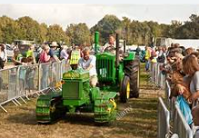
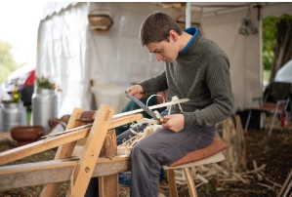
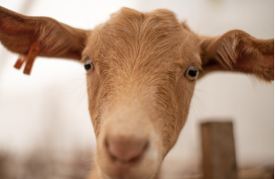
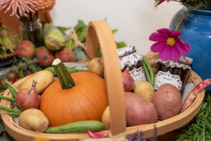
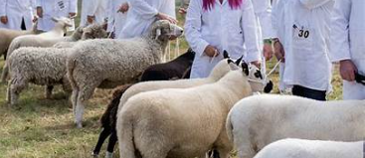
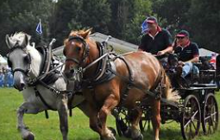

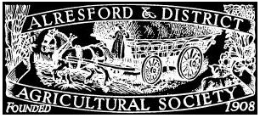

Green Sponsorship - from £125
• 2 Sponsor Badges allowing free access to the showground and to the Members Club
• 2 complimentary coffee vouchers available (on request)
• Name a single class in rings 2/3 after your company
• Tribute by commentator whilst class is in progress (wording to be supplied)
• Opportunity to present winners rosettes
• Name printed in Schedule and Programme against chosen class
• Listed on our website & Show Programme

Bronze Sponsorship - from £250
As Green sponsorship benefits (see above) plus:
• Advertising banner (that you provide)
• Invitation to Presidents Drinks Reception
• 4 Sponsor Badges allowing free access to the showground and to the Members Club
• 4 complimentary coffee vouchers available (on request)
• Name a single class in ring 1 or a livestock breed after your company
• Forward parking in our Members area

Silver Sponsorship - from £500
As Bronze sponsorship benefits (see above) plus:
• 4 Guest badges
• Name a class in the Main Ring
• A half page, black and white advert in the Show Programme
• Be part of the Society's social media campaign

Sapphire Sponsorship - from £950
As Silver sponsorship benefits (see above) plus:
• A half page, colour advert in the Show Programme
• Ringside banner plus a flag/ 'A' frame banner at the vehicle exits
• Logo on our website (to be supplied)
• Link for our website to sponsors website (to be supplied)

Gold Sponsorship - from £1,500
As Sapphire sponsorship benefits (see above) plus:
• A full page, colour advert in the Show Programme
• Discounted rates for additional tickets
• Opportunity to book a pitch on Trade Rows A, B & C

Show Partners – from £3,250
• As Gold sponsorship benefits (see above) plus a bespoke package to suit your individual requirements

