RHS MALVERN SPRING FESTIVAL 2024 BIOSECURITY POLICY & REGULATIONS

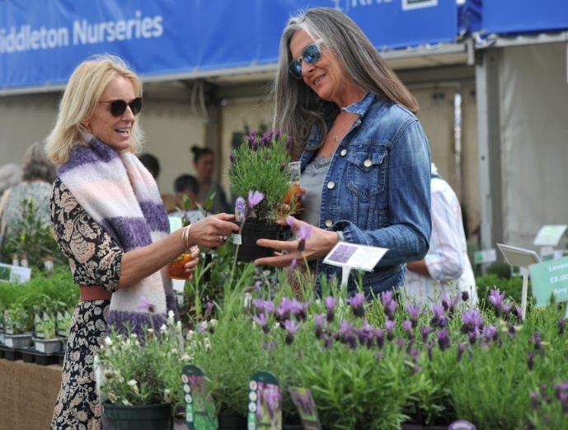
Anyone involved in RHS Malvern Spring Festival at the Three Counties Showground MUST follow the RHS Shows Biosecurity Policy & Regulations. This key document applies to any plants/plant material brought on-site (for sale, exhibition or planting/dressing purposes).
Please read the RHS Shows Biosecurity Policy & Regulations in full and refer to it when sourcing and selecting plants/plant material ahead of the Festival.
The RHS Biosecurity team carry-out plant health and compliance inspections 2 days before the Festival opens. If required, please provide relevant UK plant passports and documentation. Plants may be removed at the discretion of the RHS.
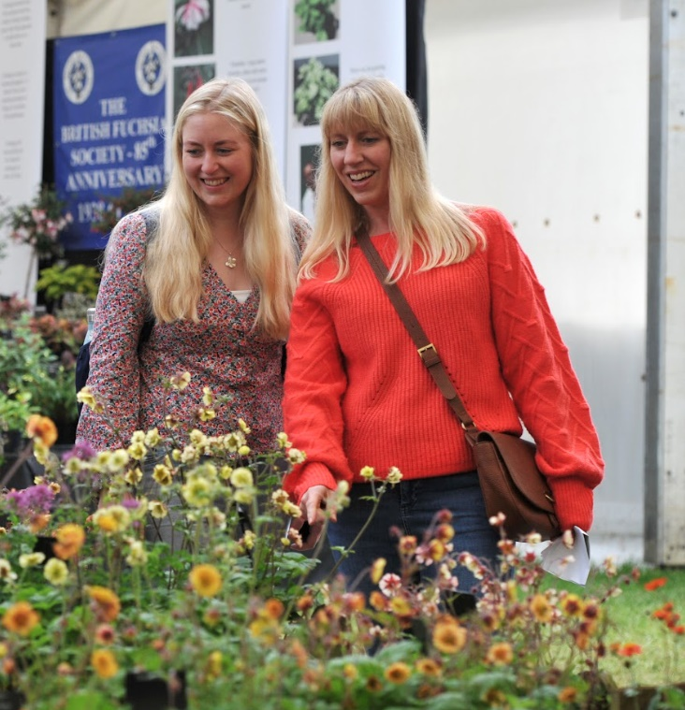

Environmental Note
PLASTIC/ARTIFICAL plants and grasses are prohibited from the site for this Show. For further information regarding plastic use restrictions at the Festival please refer to the Exhibitor Manual pages 36, 37 & 48.
Navigating the RHS Shows Biosecurity Policy & Regulations document
- Banned plant species are listed under sections 1.3 first bullet point, 1.6 & 1.8
- Restricted plant species & specifications are listed under sections 1.3 second bullet point, 1.4, 1.5, 1.6 & 1.7.
- Plant passporting is covered under section 1.2.
Contacts
For questions related to Biosecurity & Plant Health at RHS Shows please email: showsplanthealth@rhs.org.uk
For Show specific queries please contact your RHS Malvern Contact:
For Tradestands: tradestands@threecounties.co.uk
For Florals: melinda.goodhew@threecounties.co.uk
For Show Gardens and Features: charlie.gwynne@threecounties.co.uk
For all other enquiries: kate.dufton@threecounties.co.uk

