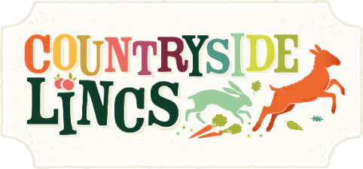

Alcohol Sales Application Form
- You must complete this form if you’re selling any products containing alcohol as you will operate under our premises licences.
- All exhibitors will be visited by our DPS on Sunday 14 April to ensure the correct paperwork is in place and that all appropriate signage is being displayed.
- No alcohol may be sold at the event, without the presence of one of the named personal licence holders listed on this form.

Contact and Product Details
Company Name:

Trading Name (if different):

Telephone: | Email:
Description of licensable product e.g. sale of bottled cider:

Details of nominated personal licence holder(s) on site at all times (continue on separate sheet if necessary)
Title: | First Name:
Surname: | License No:
Issuing authority (e.g. West Lindsey District Council):
Details of all staff selling alcohol during the event (continue on separate sheet if necessary):
First name: | Surname:
First name: | Surname:

I confirm that the above information is correct and that if any of these details change, I will contact the Lincolnshire Agricultural Society at the earliest opportunity on 01522 522900. I confirm that all staff on the trade stand will operate within the ‘Challenge 25’ policy and will not provide alcohol or alcohol-based products to anyone under the age of 18.
Please complete and return this application form to the below address by 15 March.
The Trade Team, Lincolnshire Agricultural Society, Lincolnshire Showground, Grange-de-Lings, Lincoln LN2 2NA or email trade@lincolnshireshowground.co.uk
- A £25 (£30 inc VAT) License Administration Fee will have been added to your original booking.
- A sales pack, including your authorisation to sell, will be issued during set-up of Countryside Lincs.
- Failure to comply with the Licensing Act 2003 will result in your trade stand being closed.

Signed:
Print: | Date:

