PLANT VILLAGE

FACT SHEET

Display
We supply a covered sales unit, open on three sides and 4 x 4m in size. You can choose between a 1m wide area of open ground on both sides of the structure to sell from in addition to the sales unit, total area 24m2, or a 2m wide area of open ground on both sides, total area 32m2.

All shows
Sales areas are open and accessible to the public so a well-designed area that’s easy and enjoyable to shop will help your sales. The way you display helpful cultural information and signage is of particular importance. Night screens will be provided for the tent so remember to factor these in when you design your display.

Your display will be positioned 2.5m in front of your sales unit. The display can be any shape and acts as your shop window but must be a minimum of 12m².

Storage areas will be located as close as possible to your sales unit with storage size allocated in accordance with the total size of sales area purchased.

A name sign will be supplied to be attached to the front of the covered sales unit.

Plan view of Plant Village units:

Perspective view of Plant Village unit:

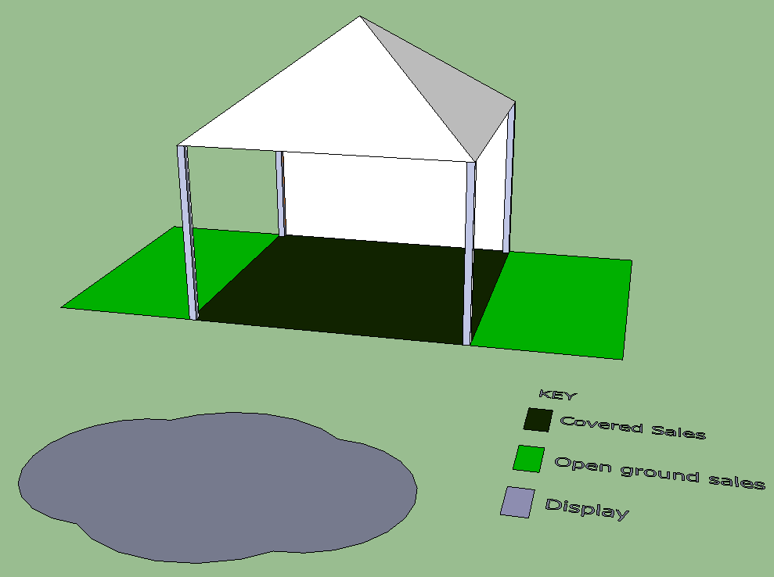

Option 1 Option 2
4x4m hat 4x4m hat
8m² open ground sales 16m² open ground sales

Total sales area 24m² Total sales area 32m²

Assessment

Plant Village displays are judged on the first day of the show and may receive either a five, four or three-flower award. One exhibit will also be selected as overall winner and will receive the ‘Best Plant Village’ award. If a display is judged to be below three-flower standard, no award will be made. £250 prize money is awarded for the ‘Best in Show’.

*Prize money correct at time of print and maybe subject to change.

Assessment criteria for each element of the display:

1 Plant material
Well grown plants, clean and free from pest and disease
Freshness and general quality of plant/flower/fruit
Range and variety of plants
Good specimen plants
Accurate and neat labelling

2 Design
The display area should cover one third of the front area and comply with the general regulations
The design should be pleasing and include appropriate plant associations
The display may be enhanced by tasteful innovation but skilful plant display will be paramount

3 Sales Area
Tidy presentation
Practicability – effective use of space for sales and storage
Sufficient access to sales area
Coherence with overall display
The sales area should have a discreet division between the front display and any sales tables/trolleys etc
Limited visual access to storage area

