PLANT PAVILION

KEY INFORMATION

Size of stand and layout

The Plant Pavilions will be assembled in blocks, sectioned off into individual units each supplied with its own covered sales area and name banner. Each covered unit is constructed of a tubular framework with a PVC covering and will have a name banner at the front. Name banners are pre-printed with a standard typeface, and will carry the exhibitor’s name (as listed in the Show Guide) and the stand number.

Immediately in front of the covered sales unit is an open display area, sectioned off from neighbouring exhibits with white picket fencing measuring 6m frontage x 6m deep or 9m frontage x 6m deep. The display area must contain a quality horticultural display and must be maintained to a high standard throughout the Show. The display must be in the front section of the unit.
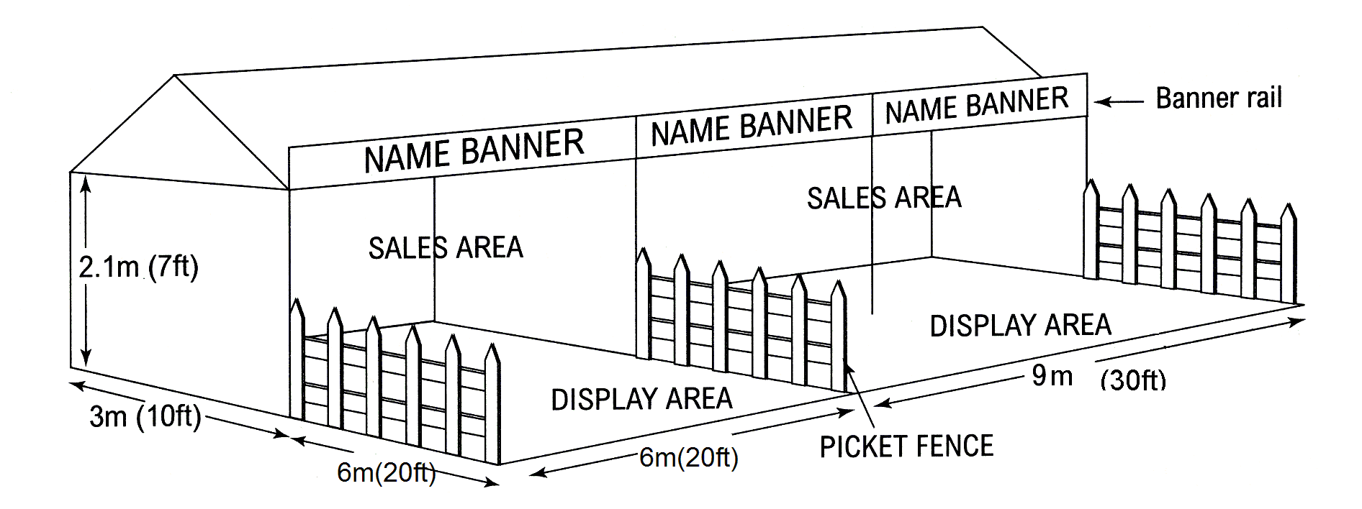
Considerations

Display
- Do you have a design that introduces originality, theatre, creativity and impact?
- Does your display act as an engaging shop window?
- How will you incorporate height and structure in the overall design?
- What plant associations will you use?
- Are the plants ‘show quality’ specimens? Are they free from pests and diseases?
- How will you make the edging in keeping with your display?

Sales Area
- What type of sales unit will you use? Tables, dressed trolleys, bespoke tiered display units, wooden boxes, shelving or some other attractive method?
- How will you dress any bare metal plant trolleys?
- Have you considered how to tastefully display cultural, and other useful plant information?
- Are the sales plants relevant to the display and in your current catalogue?
- Have you considered new and creative ways to sell in your sales are? Props can be helpful.
- Have you taken the tent night screens into account (if using) and the ease of putting them up and down on a daily basis?
- How will you secure plants in the open ground sales area overnight?
- Have you carefully considered the standard of presentation used in pricing plants and displaying offers in the sales area to ensure they are clear, accurate, tasteful and in proportion?

