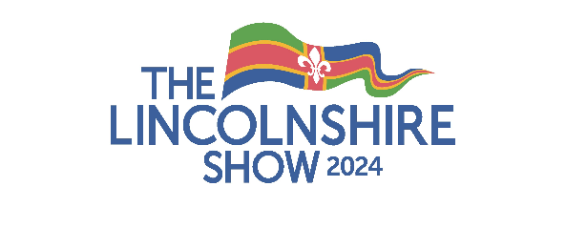
Hospitality Agreement Form

You must complete this form if your trade stand is providing alcohol or alcohol based products (falling under licensing legislation) free of charge as a sample or as part of your hospitality.
Complete the alcohol sales form if you are selling alcohol or alcohol based products.

- All traders in this category will be visited on their stands on Tuesday 18 June 2024 by our nominated Licensing Officer.
- Exhibitors must agree to operate within the ‘Challenge 25’ policy, (details of which may be found at www.wsta.co.uk/Challenge-25.html) and ensure that no alcohol is served to anyone under the age of 18 years. The Licensing Officer will inspect stands to ensure that the appropriate signage, etc is being displayed.

Company Name |  | Trading Name  (if different)
Description of alcohol to be given to visitors as part of your hospitality offering
- I confirm that the above information is correct and that if any of these details change, I will contact LAS at the earliest opportunity, telephone 01522 522900.
- I also confirm that all staff on our stand will operate within the ‘Challenge 25’ policy and will not provide alcohol or alcohol based products to anyone under the age of 18 years.
- I confirm that all alcohol will be provided on a free of charge basis.
Name |  | Signed
Email address |  | Telephone

- Complete this form and return it to Lincolnshire Agricultural Society by 31 May 2024.
- Failure to notify the Society of your approach to serving alcohol as part of your hospitality arrangements could result in you not being able to offer drinks of this nature during the Show.
- Failure to comply with the Licensing Act 2003 will result in your trade stand being closed.

