NOTES FOR HORSE AND DONKEY EXHIBITORS
ENTRY CLOSING DATES
Horse and Donkey: Monday 21st August 2023
Late entries will be accepted up to 4th September. Late entry fees are shown in brackets ().
Competitors may enter additional classes on the day – CASH ONLY.
No Member’s Discount for late entry or entry on the day.

CLASS ENTRY FEES
All PAID-UP MEMBERS of the Romsey Agricultural & Horse Show Society (RAHSS) are entitled to reduced entry fees.
Light Horse Entry fees - RAHSS Members £15, non-members £18 (£23).
Jumping, Arena Eventing, Heavy Horse and Donkeys Entry Fees and Prizes –
please see individual sections/classes for entry fees and prizes.
PLUS A FIRST AID CHARGE OF £3 PER RIDER/HANDLER
Please note - this includes Heavy Horse and Donkey handlers
PLEASE NOTE: Online entries are through “Showing Scene” – once entries open there will be a link on our website (www.romseyshow.co.uk). Payment will be taken through STRIPE.
For postal entries, cheques should be made payable to: ‘The Romsey Show’, and should be sent with the entry form to
“The Romsey Show Office, 4, The Old Carthouses, Broadlands, Romsey, Hants, SO51 9LQ”

No entry will be accepted unless signed by the Exhibitor or authorised agent and the correct entry fee, including the appropriate first aid charge(s) for ALL riders/handlers, is paid in full.
To allow classes to run to time class sizes may be limited.
INSURANCE
Competitors are required to have third party insurance cover for all riders, handlers and animals in their party.
Any person under 16 years old must be accompanied/supervised by an adult when in charge of an animal.

ENTRY TICKETS
Admission to the Main Showground will by Exhibitor Wristbands and will be provided on the basis of number of horses/ponies entered. Additional wristbands may be purchased at the special Exhibitors’ advanced rate of £16.00 with your entry. Wristbands and information will be posted 2 weeks before the show • 1 horse/pony entered - 2 wristband passes • 2 entered - 3 wristband passes • thereafter 1 wristband pass per additional horse/pony entered up to a maximum of 6 wristband passes
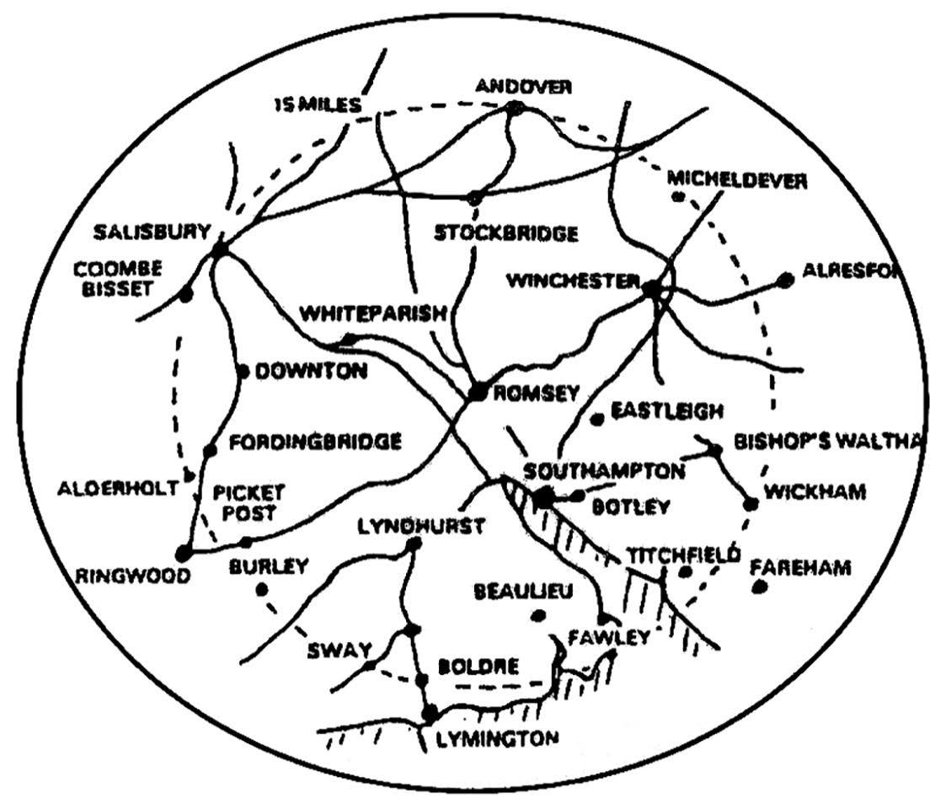
HORSE BOX passes will only be issued to and only be valid for vehicles/trailers carrying horses or ponies. Due to limited parking, and for safety, other vehicles will be required to park in the FREE CAR PARK!
Sat-Nav Postcode for the showground horsebox entrance is SO51 9LB - coordinates N 50.9777°, W 001.4854° - what3words “trying.liquid.examples”

PRIZES AND AWARDS

The society will award 1st – 6th place rosettes at the judges’ discretion.
Championship and Reserve rosettes and cards will be awarded in each championship.

A local rosette will be awarded to the best exhibit in each horse/pony class which is the property of an exhibitor living within a 15-mile radius of the Town Hall, Romsey. Those eligible must wear a WHITE arm band.
Unless otherwise stated, prize money for the Light Horse Section is as follows:
In Hand classes – 1st £20, 2nd £15, 3rd £10
Ridden Classes – 1st £25, 2nd £20, 3rd £15
Prize money cards MUST be completed by the winner and returned to the Horse Secretary’s tent on the day of the show. The money will be paid by BACS to the winner’s bank account after the show. This may take up to 2 weeks.
15 MILE RADIUS OF ROMSEY FOR LOCAL ROSETTES

CUPS AND TROPHIES
Winners of the Society’s cups and trophies must collect them from the Chief Awards Steward at the Main Show Secretary’s area before leaving the Showground, as they cannot be sent after the show. An engraver will be available at the Showground where cups and trophies can be engraved at a small charge. All cups and trophies must be returned to the Secretary, clean and undamaged by the 1st August the following year. Please do not take cups and trophies unless you can guarantee to return them safely by hand or registered post by the above date.

For any further information, additional prize lists or entry forms, please contact:
The Secretary, 4 The Old Carthouses, Broadlands, Romsey, Hants. SO51 9LQ Tel: (01794) 517521
TUBBY or TRIM
Find out how to judge a healthy body condition without scales!!

There is continuing concern about OBESE horses and ponies. Judges are continually being asked by Societies not to place over-weight animals. In conjunction with Celtic Equine Vets, the Romsey Show is offering you the opportunity to make sure you will not be penalised because your animal has stopped going to WEIGHT WATCHERS!! You could also win a prize if your animal is close to its ideal weight already.

SO WHY NOT TAKE THE CHANCE TO SEE IF YOUR ANIMAL IS FIT FOR THE JOB YOU WANT IT TO DO –

As Honorary Vets to the Show, the Celtic Equine Veterinary Practice will be present on show day providing veterinary cover, including the checking of Passports and Flu jabs. They will be located near the Horse Secretary’s tent.

If you take your animal with its showing number (back number) to the vet’s tent, at any time between 9:00 and 16:00, you can have a short demonstration of where and how precisely to take weight tape measurements, and how to use the formula, so that you can work out the weight of your animal. A copy of the instructions and diagrams will be free to take away with you.

The vets will decide which measured animals are closest to the correct weight for their type and size, and the winning owners will be sent their prizes by post after the Show, with the awards being recorded in the Show results.

NOTE - The availability of a vet at any time will obviously depend on any higher priority requirements for their services during the Show.

Celtic Equine Veterinary Practice is located in Minstead, near Lyndhurst, telephone: 02380 814155
web site: www.celticequinevets.co.uk

The Romsey Show 2023 Equine Photographer
LRG Photography
www.lrg-photography.co.uk
lrgphotography@btinternet.com or Tel: 01243 825 905
COVID 19
Any requirements regarding Covid 19 will be notified to competitors prior to the show.
Equine Influenza / Microchipping

All equines MUST be accompanied by their approved DEFRA passport.
Equine Influenza Vaccination Certificates All equines (horses, ponies, donkeys) attending the Romsey Show must have been vaccinated for Equine Influenza. Equines may attend having received the primary course, and prior to the first booster, but not within 7 days of receiving a vaccine dose. The primary course is 1st vaccination and then 2nd vaccination 21 - 92 days later. This should be followed by the first booster (150 - 215 days) and all subsequent boosters. Equines must have been vaccinated within the 6 months prior to the Show. Foals - In-foal mares that have already had vaccinations of primary Equine Influenza course should be vaccinated 4-6 weeks before the foal is due to be born. Foals should be vaccinated for Equine Influenza at 6 months to commence their primary course. A valid record of vaccination must be available on request at any time during the Show. Failure to produce evidence of vaccination may result in refusal of entry or immediate removal from the Showground. Please note that neither vaccination certificates nor passports should be sent to the Show Office prior to the event. However, random checks will be carried out on the Showground.

