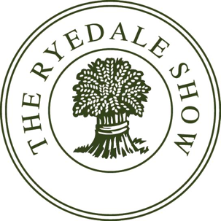
HORSES AND PONIES SECTION Timetable 2023
Please Note:
Times for classes are an approximate guide only. Classes will not start before the time stated in the Schedule.

Rings could be changed to help secure the smooth running of the show . Announcements will be made during the day .

*** RYEDALE SHOW RESERVE THE RIGHT TO AMALGAMATE OR CANCEL CLASSES IF ENTRIES ARE EXTREMELY LOW ***

Ring 2
9am – Small Breed Mountain & Moorland In Hand, followed by Championship followed by Large Breed Mountain & Moorland In Hand, followed by Championship and Supreme Large & Small Championship.
12 noon – Cleveland Bays , Followed by Championship
1.30- Best Decorated Heavy Horse

At 2pm - Rings 1 and Ring 2 will amalgamate to become the Main Ring

2pm – Parade of Vintage Tractors
2.30pm – Mounted Fancy Dress
2.50pm – Heavy Horse in Working Plough Harness
3.10pm - Presentation of the Annual Agricultural Award followed by the judging of the “Champion of Champions” and Grand Parade of Heavy Horse and Cattle Prize winners
3.50pm – Parade Of Hounds
4.10pm - Heavy Horse Turnout Class

Ring 3A/ B
9am - Hunter Breeding followed by Championships.
10.15am - In Hand Irish Draught
11:30am - Heavy Horse Young Handler. Followed by Shires & Clydesdales, judged at separate ends of the ring. Shire and Clydesdale Championships followed by Supreme Heavy Horse Championship
1pm - In Hand Coloureds, followed by Championship followed By Ridden Coloureds and Championship
3pm - Veteran Classes

Ring 4
9am – Ridden Show Hunter Pony, followed by Championship.
11.00am- Ridden Show Pony, followed by Championship
1.00pm - Ridden Mountain and Moorland

Ring 5
9am – Ridden Hunters, followed by Championship
1.15pm – Ridden Irish Draught
2.30pm - Driving Classes

Ring 6
10am – Working Hunter Pony, followed by Championship.
11.45am – Working Hunter Classes.
2.45pm - Mountain & Moorland Working Hunter Pony, followed by Championship

Ring 7
9.00am – Ridden Cobs followed by Championship.

10.30am – Riding Horse
11.30am – Novice Retrained Racehorse Class.
1.30pm - Open Retrained Racehorse Class.

Ring 8
8.30am – Dubarry Burghley Young Event Horse Classes

2.00pm - Open Retrained Racehorse Class.

Unaffiliated Show Jumping will follow the Open Retrained Racehorse class . They will be run by Alison Brown , Friars Hill Stables .Tel 01751 432758

Entry form can be found in additional documents.

